ADAMS ~Dews Plantation Rd~ Cemetery
Visited by Members of
Grave Site Survey Task Force (GSSTF)
Under the Auspices of
Isle of Wight County Historical Society (IWCHS)
May 16, 2004

This cemetery is located on “Ferguson's Perpetuity Farm" on Dews Plantation Road. At least two families are buried there, although only the ADAMS families are buried within the plat markers. Three footstones are evident with the inscriptions, “Sister”, “Father”, “Mother” in the ADAMS plat, but since the names of the deceased are all on the obelisk, it was not possible to determine the identities of the footstones.

A somewhat unusual engraving was found on the reverse side of the Confederate States of America plaque for George W. Adams. The engraving reads:

GEORGE WASHINGTON ADAMS
3rd Inf STD Age 21
June 23, 1861 Smithfield, VA
PVT CO I 2nd VA Comm Dept
Captured April 6, 1865 Released
June 22, 1865 at Point Lookout

Throughout the transcribing process, an attempt was made to preserve the, ‘look and feel’ of the original inscriptions as regards word spacing, arrangement, and possible misspellings.

Please address your comments/corrections to: albert.b@charter.net or epowellsr@aol.com.

Note # | Inscription |  | Note # | Inscription
(1) | MATTIE LEE  ADAMS  Born  Feb. 9, 1885  Died  July 14, 1888 |  | (1) | GEORGE W.  ADAMS  Born  April 15, 1840  died  March 20, 1900
(1) | GEORGEANNA  ADAMS  Born  Sept. 29, 1842  died  Sept. 3, 1906 |  | (1) | LUCINDY  ADAMS  1808 - 1888
(2) | JOSIAH B. JONES  PVT CO I 3 REGT VA INF  Confederate States Army  Jan 2 1846 Mar 28 1899 |  | (2) | MARY ELLEN WHITLEY  JONES  Nov. 22, 1849  Mar. 26, 1885

Notes:
(1) These graves are within the plat markers for the ADAMS family.
(2) These graves are adjacent to but outside the ADAMS family plat.
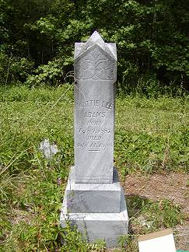 | 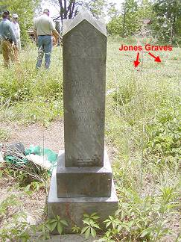
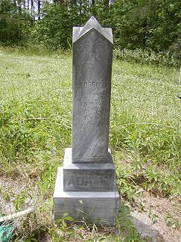 | 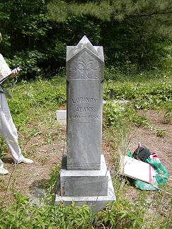
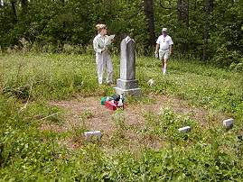 | 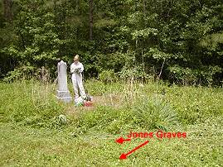
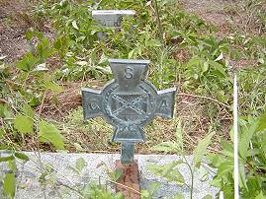 | 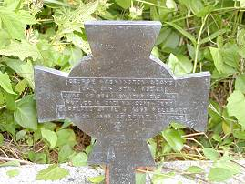
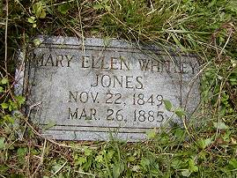 | 