Allman ~Bowling Green Rd~ Cemetery
Transcribed by members of the
Grave Site Survey Task Force (GSSTF)
Under the Auspices of
Isle of Wight County Historical Society (IWCHS)
Visited June 15, 2005

This gravesite is located in heavy underbrush behind the residence of Chip Fontaine at 15035 Bowling Green Rd.

A selection of shaving foam, water, or talcum powder was used to improve the legibility of the inscriptions on the older tombstone. Afterwards, a clean water spray was used to remove any residue. GSSTF members were careful not to damage tombstones or artifacts during the transcription process.

Throughout the transcribing process, an attempt was made to preserve the, ‘look and feel’ of the original inscriptions as regards word spacing, arrangement, and possible misspellings.

Please address your comments/corrections to: albert.b@charter.net or epowellsr@aol.com.

ROBERT ALLMAN
Born
Mar. 24, 1836
Died
July 23, 1908

“An honest man,
The noblest work
of God”

ALLMAN
R.A. [footstone]

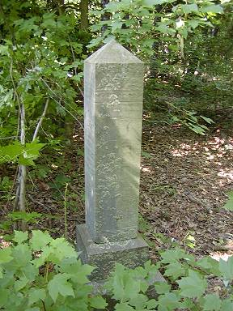 | 