Allmond ~Comet Rd~ Cemetery
Transcribed by members of the
Grave Site Survey Task Force (GSSTF)
Under the Auspices of
Isle of Wight County Historical Society (IWCHS)
Visited April 30, 2006

This small cemetery (about 20 feet square) is located about 100 yards northwestof the former Allmond (William C. Conner House c. 1815) residence on Comet Road. The site is overgrown with small bushes and weeds. According to a Mr. Raymond Edwards, who directed GSSTF team members to the site, the grandparents of Mr. George W. Allmond are buried there although there are no visible markers.

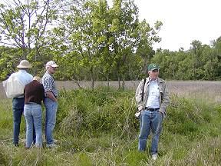

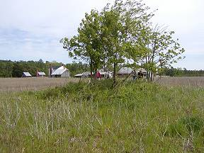

Please address your comments/corrections to: albert.b@charter.net or epowellsr@aol.com.

