Andrews ~Thomas Woods Trail~ Cemetery

Visited by Members and Volunteers of
Isle of Wight County Historical Society
January 21, 2004

This small, private cemetery is located in a field just off of Thomas Woods Trail (# 614) on the ‘Andrews Place’ about three miles from Zuni, VA. It is overgrown with weeds and not maintained although the vertical obelisk monument is quite visible from the road. Although there are only two concrete crypts with footstones, there are at least three unmarked mounds of dirt … obviously graves.

A solution of shaving cream foam and water was used to clean and improve the legibility of the inscriptions although, in some cases, not all of the inscriptions could be deciphered. Afterwards, a clean water spray was used to remove any residue. The comments between the, “[ ]” are informative comments and not inscribed on the stones. The comment [fs] indicates that the inscription is on a small footstone.

 | Inscription |  |  | Inscription
Note (1) | [obelisk monument .. side 1]  Erected by his  Beloved Wife  “Again I hope to meet  Again  When the day of life is  here  And in Heaven with joy  to greet thee.  Where no funeral [~~~~~~~]  [~~~~~~~~~~] |  |  | [obelisk monument .. side 2]  Our Mother  MAGGIE ANDREWS  1847 1918  “She came to raise  our hearts to Heaven  She goes to call us  there”
Note (1) | [obelisk monument side 3]  Blackwater Lodge [~~~~~~~~]  J. J. ANDREWS  Born Aug. 10, 1835  Died Feb. 27, 1906  Age 70 yrs. 6 mos  17 days  “Was made a Mason June 21,  1851 and served as Steward  for many years”

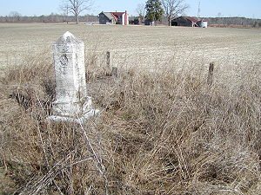 | 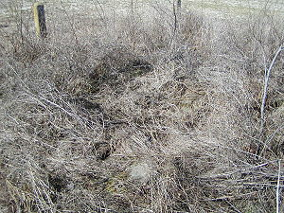
Obelisk with inscriptions on 3 sides | Unmarked dirt mounds … graves?
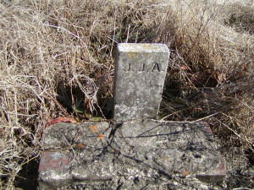 | 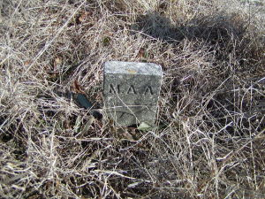
Footstone – J. J. Andrews | Footstone – Maggie A. Andrews
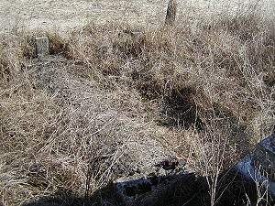
Crypt Stones – J.J.A. and M.A.A.

Notes:

(1) The marks, “[~~~~~~~~~~~]” indicate that the inscription is not decipherable.

