Bailey ~Bowling Green Rd~ Cemetery
Transcribed by members of the
Grave Site Survey Task Force (GSSTF)
Under the Auspices of
Isle of Wight County Historical Society (IWCHS)
Visited July 24, 2005

This small cemetery is located in a field behind a private residence in the 11000 block of Bowling Green Road. As customary with the task force members, if a formal cemetery name is not available, the cemetery will carry the last name of its majority deceased, thus the name, “BAILEY” for this report.

A selection of shaving foam, water, or talcum powder was used to improve the legibility of the inscriptions on the older tombstones. Afterwards, a clean water spray was used to remove any residue. GSSTF members were careful not to damage tombstones or artifacts during the transcription process.

Any text within the “[ ]” is a comment about the tombstone inscription, ex., [fs] indicates a footstone inscription. Throughout the transcribing process, an attempt was made to preserve the, ‘look and feel’ of the original inscriptions as regards word spacing, arrangement, and possible misspellings.

Please address your comments/corrections to: albert.b@charter.net or epowellsr@aol.com.

 | Inscription |  |  | Inscription
 | ROBERT BAILEY  Dec. 24, 1974 |  |  | SHERMAN BAILEY  Jan. 10, 1923  Jan 14, 1996
 | RHODA E. BAILEY  July 23, 1927  Sept. 22, 1997 |  |  | SAMUEL BAILEY SR  Jan. 10, 1923  Feb. 13, 2000  Pretlow & Chapman

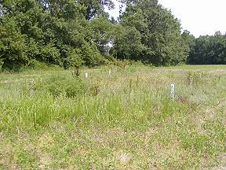 | 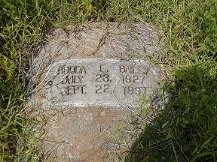
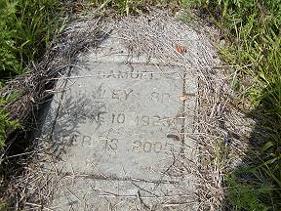 | 