Barlow (Dews Plantation) ~Green Level Rd~ Cemetery
Transcribed by members of the
Grave Site Survey Task Force (GSSTF)
Under the Auspices of
Isle of Wight County Historical Society (IWCHS)
Visited July 24, 2005

This cemetery is located in the front yard of a private residence on Green Level Road with all of the inscription stones invisible underneath the grass. The sod was removed so the inscriptions could be copied and then carefully replaced so that the yard was minimally disturbed. The homeowner reported that she remembered there being seven graves although GSSTF members could locate only six.

A selection of shaving foam, water, or talcum powder was used to improve the legibility of the inscriptions on the older tombstones. Afterwards, a clean water spray was used to remove any residue. GSSTF members were careful not to damage tombstones or artifacts during the transcription process.

Any text within the “[ ]” is a comment about the tombstone inscription, ex., [fs] indicates a footstone inscription. Throughout the transcribing process, an attempt was made to preserve the, ‘look and feel’ of the original inscriptions as regards word spacing, arrangement, and possible misspellings.

Please address your comments/corrections to: albert.b@charter.net or epowellsr@aol.com.

 | Inscription |  |  | Inscription
 | SIDNEY BARLOW  Aug. 31, 1907  May 29, 1908 |  |  | E. HUDSON BARLOW  Aug. 10, 1873  June 5, 1907
 | OCTAVIUS W. BARLOW  Nov. 8, 1856  June 15, 1902 |  |  | Infant  SHERMAN P. BARLOW  [no dates or other inscriptions]
 | J. PLENNY BARLOW  June 2, 1859  Aug. 3, 1932 |  |  | ISABELL C. GWALTNEY  wife of  J. H. BARLOW  Born July 17, 1832  Died Dec. 14, 1900

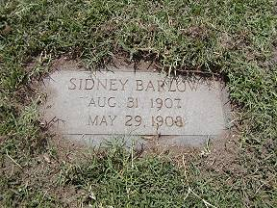 | 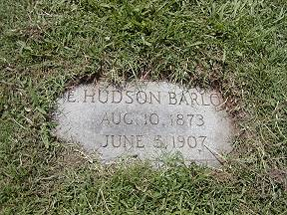
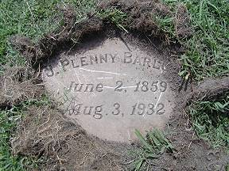 | 