Batten ~Founders Pointe Development~ Cemetery
Transcribed by members of the
Grave Site Survey Task Force (GSSTF)
Under the Auspices of
Isle of Wight County Historical Society (IWCHS)
Visited June 15, 2005

This cemetery is located within the Founders Pointe development area and has been well marked to prevent destruction by the ever-present bulldozers. The drawing on page 3 was obtained from the developer and is included for information purposes … it seems to indicate the presence of three graves although there was only one tombstone visible.

The assistance of the developer is gratefully acknowledged, especially that of Chuck Carlisle, Sales Executive, CSP who donned his boots and went into the heavy undergrowth with the Gravesite Survey Task Force (GSSTF) members.

A selection of shaving foam, water, or talcum powder was used to improve the legibility of the inscriptions on the older tombstone. Afterwards, a clean water spray was used to remove any residue. GSSTF members were careful not to damage the tombstone or artifacts during the transcription process.

Throughout the transcribing process, an attempt was made to preserve the, ‘look and feel’ of the original inscriptions as regards word spacing, arrangement, and possible misspellings.

Please address your comments/corrections to: albert.b@charter.net or epowellsr@aol.com.

Sacred to memory
EDMUND BATTEN
Who departed this life
January 3rd A.D. 1854
Blessed be the bark that waft
us to the shore
Where death derided friends shall
part no more
to joine thee there. Here with
dust repose us all
the hope thy happiness, many knows
this memento is erected
by his bereaved widow
Mary A. Batten

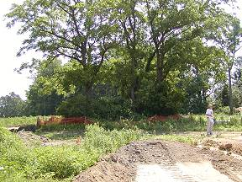 | 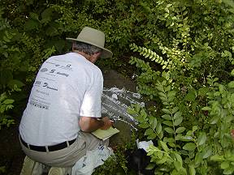
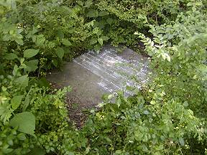 | 