Beale-Saunders ~Airport Rd~ Cemetery
Transcribed by members of the
Grave Site Survey Task Force (GSSTF)
Under the Auspices of
Isle of Wight County Historical Society (IWCHS)
Visited April 5, 2006

This cemetery is located in a local sandpit near the end of a gravel road near Franklin and almost at the Blackwater River. The cemetery is somewhat unusual in that the entire top is vaulted over with concrete and has upward protuberances over existing graves as well as protuberances over unmarked areas (see the first two pictures below).

GSSTF members were careful not to damage tombstones or artifacts during the transcription process.

Any text within the “[ ]” is a comment about the tombstone inscription, ex., [fs] indicates a footstone inscription. Throughout the transcribing process, an attempt was made to preserve the, ‘look and feel’ of the original inscriptions as regards word spacing, arrangement, and possible misspellings.

Please address your comments/corrections to: albert.b@charter.net or epowellsr@aol.com.

 | Inscription |  |  | Inscription
 | HOLOMAN P. SAUNDERS  Dec. 23, 1886  Oct. 16, 1953 |  |  | SAUNDERS  J. PARKER CAROLINE B.  1834 – 1890 1846 – 1926
 | JOBIE P. SAUNDERS  Nov. 28, 1888  June 16, 1954 |  |  | BEALE  SPIKES E. NANCY E.  1811 – 1884 1821 – 1893
ALGIE H. MARGARET
SAUNDERS BEALE
1877 – 1925 1848 - 1881

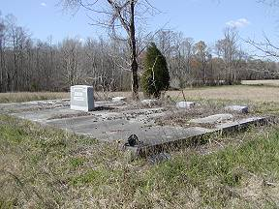 | 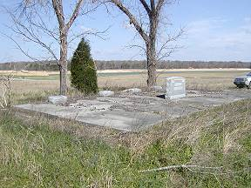
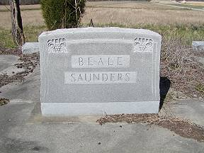 | 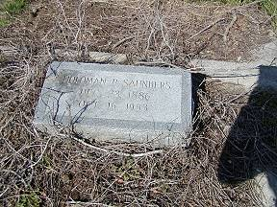
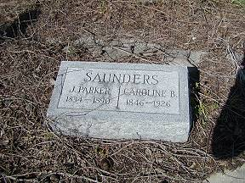 | 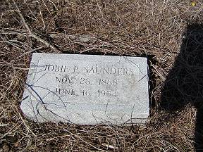
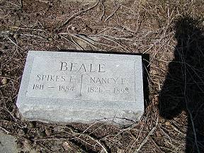 | 