Beaton ~Mill Creek Rd~ Cemetery
Transcribed by members of the
Grave Site Survey Task Force (GSSTF)
Under the Auspices of
Isle of Wight County Historical Society (IWCHS)
Visited September 28, 2005

A selection of shaving foam, water, or talcum powder was used to improve the legibility of the inscriptions on the older tombstones. Afterwards, a clean water spray was used to remove any residue. GSSTF members were careful not to damage tombstones or artifacts during the transcription process.

Any text within the “[ ]” is a comment about the tombstone inscription, ex., [fs] indicates a footstone inscription. Throughout the transcribing process, an attempt was made to preserve the, ‘look and feel’ of the original inscriptions as regards word spacing, arrangement, and possible misspellings.

Please address your comments/corrections to: albert.b@charter.net or epowellsr@aol.com.

 | Inscription |  |  | Inscription
 | JOHN H. BEATON  Born  Aug. 30, 1831  died Aug. 31, 1910  ----  His life was an exemplary  one throughout  ----  And his wife  MARTHA A. BEATON,  Born July 25, 1834.  Died Feb. 23, 1911  ----  “She hath done what she could”  BEATON |  |  | WILLIAM T.,  Born  Jan. 26, 1866  Died Sept. [illegible] 1871  ----  Though lost to sight to  memory dear.  ----  MATTIE G.,  Born August 1873,  Aged one month.  ----  Our Loved One.  ----  ANNIE L.  Born Oct. 1859,  Aged two weeks  ----  Budded on earth to bloom in  Heaven  ----  Children of  J. H. & M. A. BEATON
 | CHARLES W.  Infant son of  C. B. & S. A. CRUMPLER,  Born May 20, 1871,  Died Mar. 2, 1872.  ----  We will meet again |  |  | EFFIE J.  wife of  J. P. BEALE  And daughter of  J. H. & M. A. BEATON,  Born August 28, 1875,  Married Nov. 28, 1894  Died Jan. 5, 1897  ----  “Fold her, O Father be thine arms  And let her henceforth be  A messenger of love between  Our human hearts and thee”  ----  LLOYD BEATON BEALE  Born Sept. 25, 1896,  Died May 18, 1897  ----  It was an angel that visited the  green earth and took the flower  away.

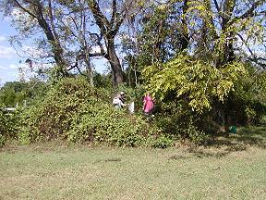 | 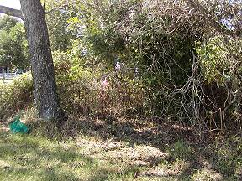
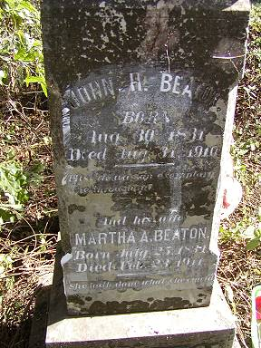 | 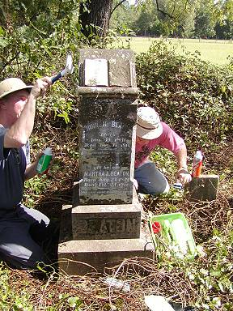
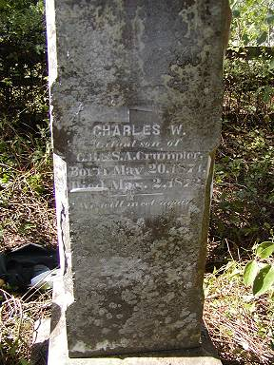 | 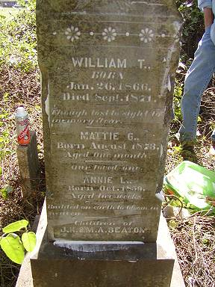
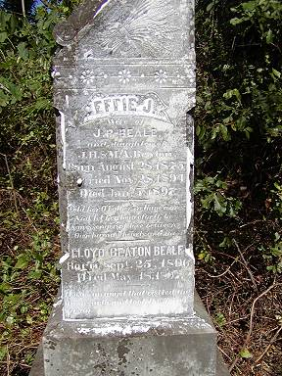 | 