Benns Church ~Benns Church Blvd~ Cemetery
Transcribed by members of the
Grave Site Survey Task Force (GSSTF)
Under the Auspices of
Isle of Wight County Historical Society (IWCHS)
Visited August 30, 2005

The single grave in front of the Church contains the remains of George Benn, Esq. He was moved to this location in order to be near the church that bears his name.

Sacred
To the memory of
GEORGE BENN ESQ.
Who departed this life
On the 9th day of November 1815
Aged 51 years

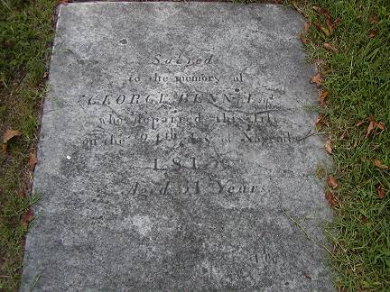

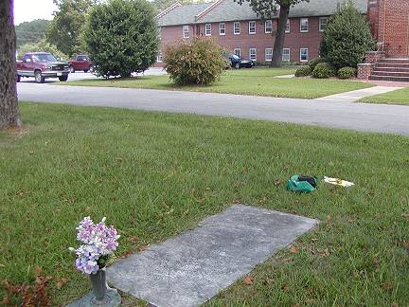

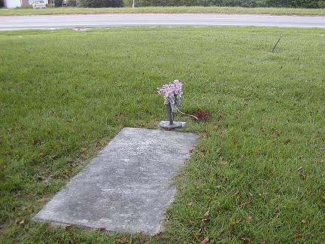

Please address your comments/corrections to: albert.b@charter.net or epowellsr@aol.com.

