Bowden ~Sandpit Rd~ Cemetery
Transcribed by members of the
Grave Site Survey Task Force (GSSTF)
Under the Auspices of
Isle of Wight County Historical Society (IWCHS)
Visited August 7, 2005

A selection of shaving foam, water, or talcum powder was used to improve the legibility of the inscriptions on the older tombstones. Afterwards, a clean water spray was used to remove any residue. GSSTF members were careful not to damage tombstones or artifacts during the transcription process.

Any text within the “[ ]” is a comment about the tombstone inscription, ex., [fs] indicates a footstone inscription. Throughout the transcribing process, an attempt was made to preserve the, ‘look and feel’ of the original inscriptions as regards word spacing, arrangement, and possible misspellings.

Please address your comments/corrections to: albert.b@charter.net or epowellsr@aol.com.

 | Inscription |  |  | Inscription
Note (1) | BOWDEN  GRACE P. SOLOMON R.  1903 – 1981 1893 – 1946  and  Daughter and Sons |  |  | [5 concrete slabs with no visible inscriptions]
 | LIZZIE B. DICKERSON  April 28, 1891  July 20, 1974 |  |  | R. H. DICKERSON, SR.  Sept. 9, 1889  April 6, 1964
 | JOHN T. JOYNER  1857 – 1930 |  |  | [9 concrete slabs without names or initials]
 | SMITH  IDA MAE GODLEY  March 28, 1934  September 20, 1994  Treasured memories of  everlasting love. |  |  | Mother  JOSEPHINE GAY  1881 - 1916
 | [unmarked grave with flowers] |  |  | PAUL EUGENE SHEFFIELD  Dec. 11, 1956  Mar. 15, 2000
 | [metal marker]  EVA JOYNER GILES  1898 - 1989 |  |  | [metal marker]  WYMAN BOY GILES  1922 – 2005
 | ROLLIE M.  GILES  Virginia  Pvt. 31S Inf.  80 Div  March 23, 1937 |  | Note (2) | E. LINWOOD TUCK  Feb. 16 1911  Jan 7 1924  A precious one from us has  gone, a voice we loved is sti  llied, a place is vacant in our  home, which never can be filled.  E.L.T. [fs]

Notes:
(1) The daughter’s name is “Gladys”, according to an old-time Zuni resident who accompanied the GSSTF team.
(2) The misplaced letters and misspelled word, “stilled” is actually engraved this way on the tombstone … not a typo.

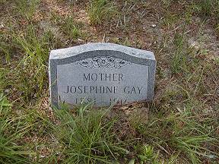 | 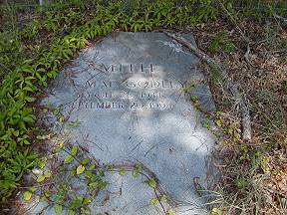
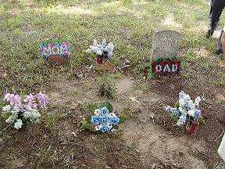 | 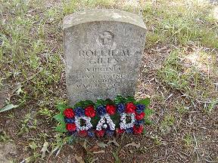
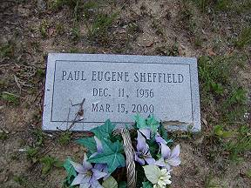 | 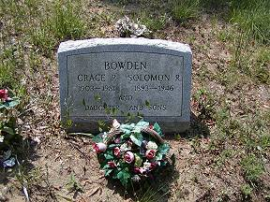
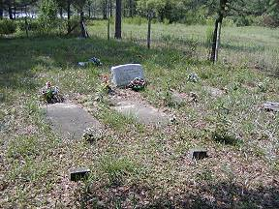 | 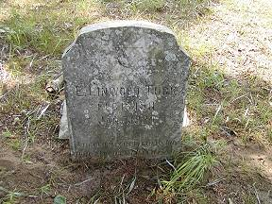
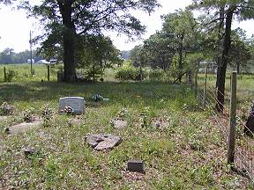 | 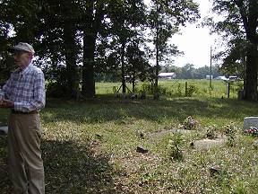
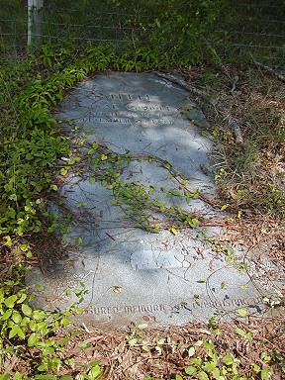 | 