Bridger ~Antioch Rd~ Cemetery
Transcribed by members of the
Grave Site Survey Task Force (GSSTF)
Under the Auspices of
Isle of Wight County Historical Society (IWCHS)
Visited March 26, 2006

This cemetery is heavily overgrown with dense brush and vines, making it very difficult to obtain access to the few tombstones visible. Team members were able to clear enough undergrowth to access the tombstones and concrete of one of the crypts in a search for inscriptions.

GSSTF members were careful not to damage tombstones or artifacts during the transcription process.

Any text within the “[ ]” is a comment about the tombstone inscription, ex., [fs] indicates a footstone inscription. Throughout the transcribing process, an attempt was made to preserve the, ‘look and feel’ of the original inscriptions as regards word spacing, arrangement, and possible misspellings.

Please address your comments/corrections to: albert.b@charter.net or epowellsr@aol.com.

 | Inscription |  |  | Inscription
 | MILLS L. BRIDGER  May 2, 1868  Aug. 12, 1909  “He died as he that trusting in the Lord.  His last words, “Meet me there.” |  |  | E. WASHINGTON BRIDGER  April 14, 1821  Aug. 29, 1898  Asleep in Jesus

Notes:
According to a family member, the following persons are also buried in this cemetery although there are no visible markers:

JOHN THOMAS BRIDGER
May 3, 1872
Mar. 17, 1930

MARTHA ANN
ELIZABETH BARRETT BRIDGER
Sep 14, 1836
Oct 4, 1915

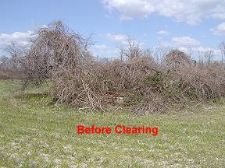 | 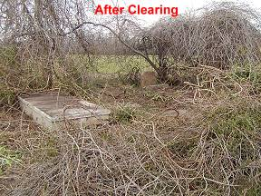
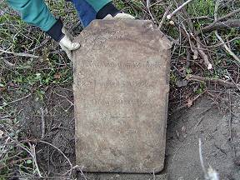 | 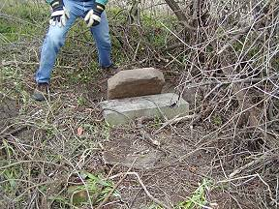
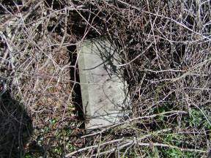 | 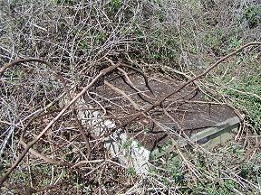
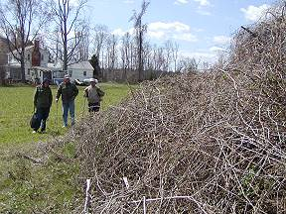 | 