Butler ~Blue Ridge Tr~ Cemetery
Transcribed by members of the
Grave Site Survey Task Force (GSSTF)
Under the Auspices of
Isle of Wight County Historical Society (IWCHS)
Visited November 30, 2005

A selection of shaving foam, water, or talcum powder was used to improve the legibility of the inscriptions on the older tombstones. Afterwards, a clean water spray was used to remove any residue. GSSTF members were careful not to damage tombstones or artifacts during the transcription process.

Any text within the “[ ]” is a comment about the tombstone inscription, ex., [fs] indicates a footstone inscription. Throughout the transcribing process, an attempt was made to preserve the, ‘look and feel’ of the original inscriptions as regards word spacing, arrangement, and possible misspellings.

Please address your comments/corrections to: albert.b@charter.net or epowellsr@aol.com.

 | Inscription |  |  | Inscription
 | MARY KNIGHT WEAVER  Wife of  C. H. WEAVER  July 20, 1880  Dec. 4, 1934  ----  Gone, but not forgotten |  | Note (1) | L.C.L. [fs]
Note (1) | B. B. [fs] |  |  | WEAVER  Rest in Peace  NANCY ANN WEAVER  Born  June 29, 1852  Died  July 2, 1918  ----  N.A.W. [fs]
Note (2) | REV. A. D. WEAVER  1880 – 1950  REV. ADOLOPUS  DEWITT WEAVER |  |  | ALVIN P. JACKSON  Apr. 4, 1901  Feb. 7, 1936  ----  He died as he lived, a Christian  A.P.J. [fs]
 | [empty space .. depression in ground] |  |  | Mrs. ROSA E. BUTLER  Died June 28, 1942
Note (3) | BELVA BUTLER  Died  Oct. 16, 1897,  Aged 82 yrs.  ----  JOSEPH BUTLER  Died  June 15, 1895  Aged 52, yrs.  ----  BUTLER |  | Note (4) | CORA E. JACKSON  Born  Dec. 1, 1879.  Aged 25, yrs.  ----  S. P. BUTLER.  Born  June 7 1885.

Notes:
- These are footstones with these initials on them … no other stones or markings are visible.
- This inscription is on a metal marker.
- These inscriptions are on one side of an obelisk.
- These inscriptions are on another side of the obelisk in Note (3).

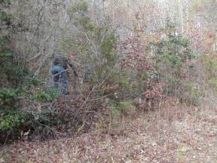 | 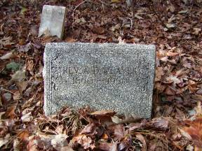
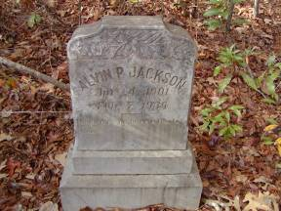 | 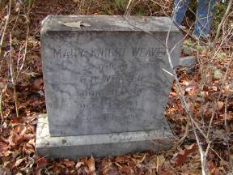
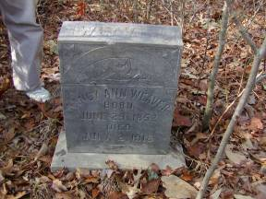 | 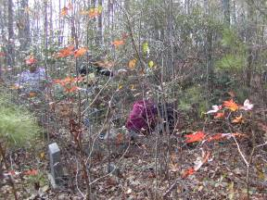
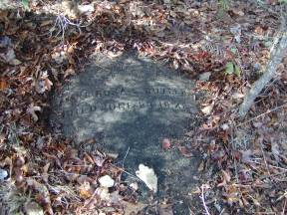 | 