Butler ~Five Forks Rd~ Cemetery
Visited by Members of
Grave Site Survey Task Force (GSSTF)
Under the Auspices of
Isle of Wight County Historical Society (IWCHS)
January 29, 2006

This small cemetery is located in a farm field at 14548 Five Forks Road and is somewhat poorly maintained with tombstones askew, one broken, and heavy undergrowth. A selection of shaving foam, water, or talcum powder was used to improve the legibility of the inscriptions on the older tombstones. Afterwards, a clean water spray was used to remove any residue. GSSTF members were careful not to damage tombstones or artifacts during the transcription process.

Any text within the “[ ]” is a comment about the tombstone inscription, ex., [fs] indicates a footstone inscription. Throughout the transcribing process, an attempt was made to preserve the, ‘look and feel’ of the original inscriptions as regards word spacing, arrangement, and possible misspellings.

Please address your comments/corrections to: albert.b@charter.net or epowellsr@aol.com.

 | Inscription |  |  | Inscription
 | Sleep Jesus  WALLACE BUTLER  Born  Jan. 21, 1883  Died  Aug. 29, 1914  Just As The Morning of His  Life was opening into day  His young and lovely spirit  Passed from earth and grief  Away.  W.C.B. [fs] |  |  | MILTON N.  Son of  W. C. & E. M. BUTLER  Aug. 10, 1914  May 29, 1915  Our Loved One  M.N.B. [fs]
 | LEONA M. BUTLER  Born  Apr. 9, 1887  Died  Dec. 16, 1903  Asleep in Jesus  [indecipherable, stone is broken along next line]  L.M.B. [fs] |  |  | In Memory of  OSCEOLA M.  BUTLER  Born  Mar. 30, 1879  Died  Sept. 17, 1880  A precious gift so  soon recalled.  O.M.B. [fs]
 | In Memory of  PATTIE A.  BUTLER  Born  March 10, 1889  Died  Dec. 4, 1892  Budded on earth to  bloom in heaven.  P.A.B. [fs] |  |  | MILTON J.  BUTLER  Born  Apr. 24, 1847  Died  Nov. 3, 1889  Our Father Has Gone  Before to Greet Us on  The Blissful Shore.  M.J.B. [fs]
BETTIE V.
BUTLER
Born
Feb. 10, 1843
Died
Apr. 6, 1914
Stranger tread
lightly my mother
lies here.
B.V.B. [fs]

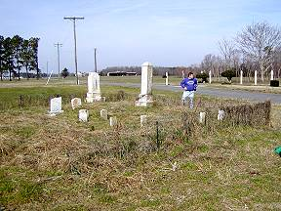 | 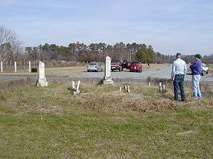
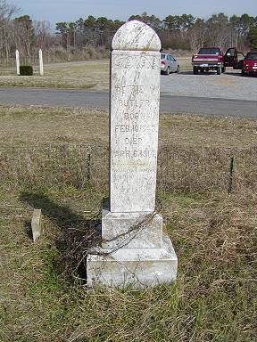 | 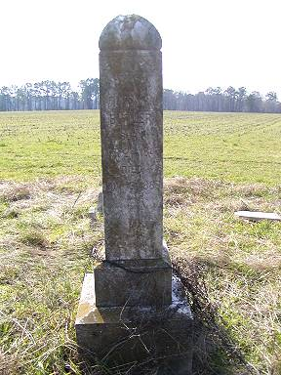
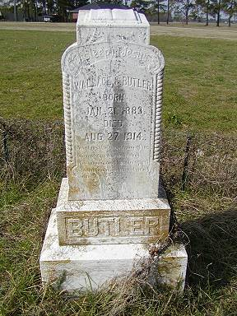 | 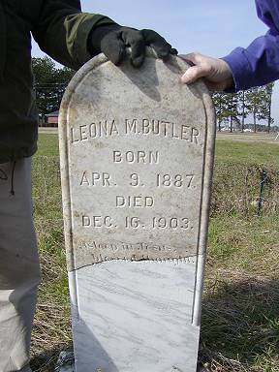
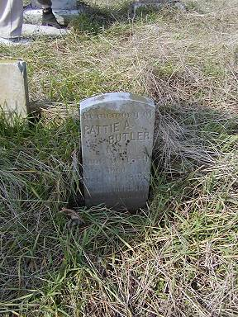 | 