BUTLER ~Sunset Dr~ Cemetery
Visited by Members of
Grave Site Survey Task Force (GSSTF)
Under the Auspices of
Isle of Wight County Historical Society (IWCHS)
April 7, 2004

This small cemetery is located in a field at the intersection of Sunset Drive (hwy # 609) and Walters Hwy (# 258). There is a single obelisk stone about 5 feet high and the names are engraved on two sides of the obelisk with the name, BUTLER engraved at the base on one side

Throughout the transcribing process, an attempt was made to preserve the, ‘look and feel’ of the original inscriptions as regards word spacing, arrangement, and possible misspellings.

Please address your comments/corrections to: albert.b@charter.net or epowellsr@aol.com.

 | Inscription |  |  | Inscription
 | ANNIE LEE  BUTLER  Nov. 11, 1867  Aug. 9, 1871 |  |  | MISSOURI ELER  BUTLER  Oct. 1, 1870  Aug. 10, 1875
Note (2) | STEPHEN DECATUR  BUTLER  Born  Nov. 3, 1804  Died  Nov 3, 1851 |  |  | RICHARD YOUNG  BUTLER  Mar. 21, 1848  Oct. 16, 1930
 | ANN MISSOURI  BUTLER  May 30, 1844  Mar. 2, 1906 |  | Note (1) | ELIZABETH HOLLAND BUTLER  Born Nov 19, 1804  Died Dec 29, 1885

Notes:
- This information was added due to information furnished by a relative … it was inadvertently omitted in the original report.
- The original date of death “Dec 29, 1885” was in error … it was corrected by a relative.
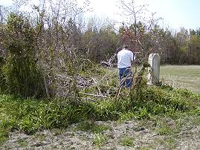 |  | 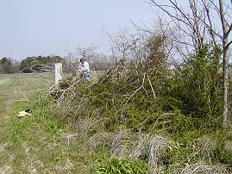
 | 