Byrd ~Whitehouse Rd~ Cemetery
Transcribed by members of the
Grave Site Survey Task Force (GSSTF)
Under the Auspices of
Isle of Wight County Historical Society (IWCHS)
Visited July 10, 2005

This small cemetery is tucked away in the woods beside a crop field and was identified by a resident who was aware of its location. GSSTF members were careful not to damage tombstones or artifacts during the transcription process.

Throughout the transcribing process, an attempt was made to preserve the, ‘look and feel’ of the original inscriptions as regards word spacing, arrangement, and possible misspellings.

Please address your comments/corrections to: albert.b@charter.net or epowellsr@aol.com.

 | Inscription |  |  | Inscription
 | GEORGE HENRY BYRD  May 11, 1909  May 2, 1962  Bradby Service |  |  | ALEXANDER BYRD  Aug. 9, 1889  Sept 16, 1959

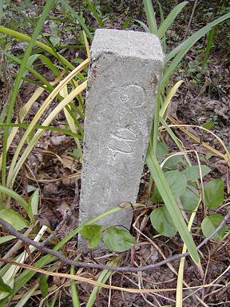 | 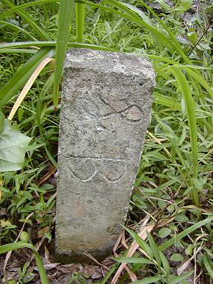
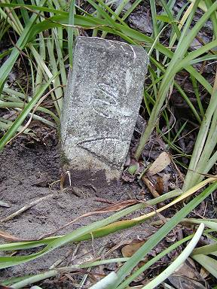 | 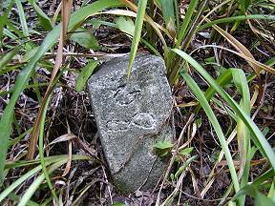
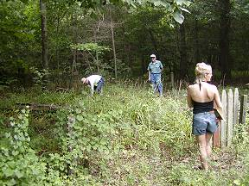 | 