Channell ~Channell Way~ Cemetery
Visited by Members of
Grave Site Survey Task Force (GSSTF)
Under the Auspices of
Isle of Wight County Historical Society (IWCHS)

This small family cemetery is located off of Carrollton Blvd (# 17) on farmland about 5 miles from Smithfield. It has been well maintained and the tombstones are in good condition.

A selection of shaving foam, water, or talcum powder was used to improve the legibility of the inscriptions on the older tombstones. Afterwards, a clean water spray was used to remove any residue. GSSTF members were careful not to damage tombstones or artifacts during the transcription process.

Any text within the “[ ]” is a comment about the tombstone inscription, ex., [fs] indicates a footstone inscription. Throughout the transcribing process, an attempt was made to preserve the, ‘look and feel’ of the original inscriptions as regards word spacing, arrangement, and possible misspellings.

Please address your comments/corrections to: albert.b@charter.net or epowellsr@aol.com.

 | Inscription |  |  | Inscription
Note (1) | PVT  GEORGE F CHANNELL  Co B & D  13 & 5 VA Cav  CSA  Jan 8 1926  Jan 8 1897 |  | Note (1) | Sacred  to the memory of  ARTHUR CHANELL  Born Feb 18, 1782  Died: June 5, 1858  A.C. [fs]
 | In memory of  MARY D  Wife of  ARTHUR CHANELL  Born Nov. 14 1797  Died Oct. 7, 1862  M.D.C. [fs] |  |  | In memory of  EMMA R.  Wife of  G. F. CHANELL  Born Sep 17 1845  Died Mar. 21, 1873  E.R.C. [fs]
Sacred
to the memory of
JOHN M. PASTEUR
who departed this life
Jan. 11th 1854
In the 29th year of
his age

J.M.P. [fs]

NOTES:
(1) The family name, “CHANNELL” or, “CHANELL” is spelled both ways on the tombstones; although it is spelled, “CHANNELL on the road sign.

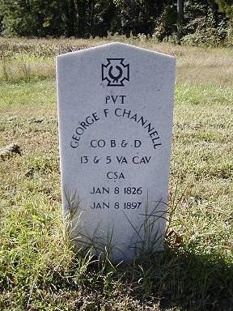 | 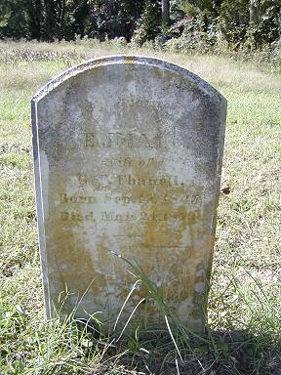
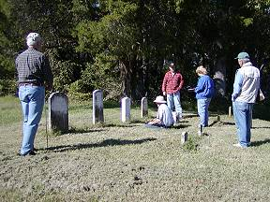 | 