Clements ~Antioch Rd~ Cemetery
Transcribed by members of the
Grave Site Survey Task Force (GSSTF)
Under the Auspices of
Isle of Wight County Historical Society (IWCHS)
Visited May 13, 2005

This small cemetery is located in the woods adjacent to Antioch Church and has not been maintained … forest debris and weeds make access difficult.

In addition to the names transcribed in this report, a search of courthouse records revealed more information about this cemetery. Notes taken from these records are included verbatim at the end of this report and have not been further edited.

A selection of shaving foam, water, or talcum powder was used to improve the legibility of the inscriptions on the older tombstones. Afterwards, a clean water spray was used to remove any residue. GSSTF members were careful not to damage tombstones or artifacts during the transcription process.

Any text within the “[ ]” is a comment about the tombstone inscription, ex., [fs] indicates a footstone inscription. Throughout the transcribing process, an attempt was made to preserve the, ‘look and feel’ of the original inscriptions as regards word spacing, arrangement, and possible misspellings.

Please address your comments/corrections to: albert.b@charter.net or epowellsr@aol.com.

 | Inscription |  |  | Inscription
Note (1) | JOHN R.  CLEMENTS  Feb. 7, 1830.  Oct. 21, 1884.  Rock of Ages  Cleft for Me  Father  J.R.C. [fs]  MARGARET  CLEMENTS  Aug. 5, 1829  June 25, 1905  Asleep in Jesus  Blessed sleep  Mother  M.C. [fs] |  |  | In Memory of  RICHARD CLEMENTS  Born Aug. 17, 1827  Died July 2, 1873  -----------  Our brother left this world  of woe for regions of eternal love,  twas God who called him from below  to join in praising Him above  R.C. [fs]

Notes:
(1) An obelisk tombstone with the names as inscribed vertically.

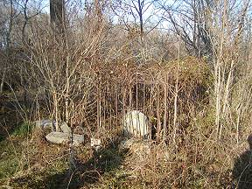 | 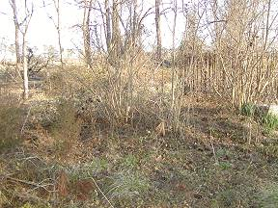
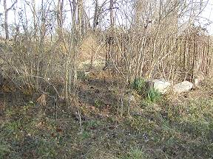 | 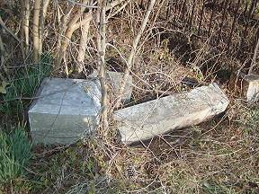
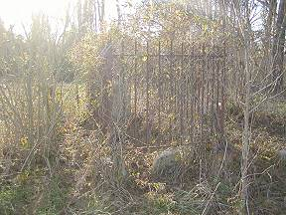 | 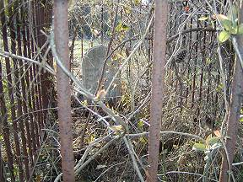

Here's what I know about the Clements family. (Still need dates for John R, Margaret & Richard). This family (not sure exactly which one, but recall seeing deeds at courthouse) donated the land for the church cemetery.

Hope it helps
annemarie

Monroe Clements (born abt 1803 - died 1852) m. Mary (last name unknown might be Atkinson) they had:

Richard Clements - buried behind Antioch - Fought w/ 24th Va Cavalry

John R Clements - buried behind Antioch - m. Margaret Worrell 15 Apr 1861 in Southampton Co. (see John & Margaret below for children. John fought w/16th Va Inf, 62nd Ga & 24th Va Cav

Thomas J Clements - buried at Antioch - m. Nancy Polk Gay 23 May 1864. see children below. fought w/16th Va Inf.

Fabius Clements - listed only on census records, have not found any info on him.

children of John & Margaret (lived to adults only)
Charles M. Clements (buried at Antioch) m. Clara Snipes

Whitty W Clements (buried at Antioch) m. Charlie Edward Saunders.

children of Thomas & Nancy

Ida Mary Clements

Eustace Atkins Clements (buried at Mt Carmel) m. Annie
Maud Duck

Ruth Clements (buried at Antioch )

Thomas Josiah Clements (buried at Antioch died at age 14)

Fabius M Clements (buried at Antioch ) m. Lucy Ballard

