Cofer ~Apache Tr (off of Muddy Cross Rd)~ Cemetery
Transcribed by members of the
Grave Site Survey Task Force (GSSTF)
Under the Auspices of
Isle of Wight County Historical Society (IWCHS)
Visited June 1, 2005

This small cemetery has been immaculately maintained, the grass trimmed, tree limbs and other debris removed (except for one pile of brush near the access road). GSSTF members (as well as the cemetery custodian) were not aware of any official name for the cemetery so as customary in such instances, named the cemetery after the last name of the majority of the deceased.

A selection of shaving foam, water, or talcum powder was used to improve the legibility of the inscriptions on the older tombstones. Afterwards, a clean water spray was used to remove any residue. GSSTF members were careful not to damage tombstones or artifacts during the transcription process.

Any text within the “[ ]” is a comment about the tombstone inscription, ex., [fs] indicates a footstone inscription. Throughout the transcribing process, an attempt was made to preserve the, ‘look and feel’ of the original inscriptions as regards word spacing, arrangement, and possible misspellings.

Please address your comments/corrections to: albert.b@charter.net or epowellsr@aol.com.

 | Inscription |  |  | Inscription
 | JAMES COFER  Nov. 6 1888  Jan 25 1964 |  |  | WILLIAM COFER  Died June 8 1952
 | ABRAHAM E COFER  Born Sept 6 1909  Died Nov 19 1960 |  |  | MARY E BYRD  Died May 9 1946
 | SARAH GOODRICH  Jan 11 1986 |  |  | JOSEPH E PITTMAN  May 17 1896  June 5 1975
 | QUEEN PITTMAN  Oct 23 1897  June 17 1964 |  |  | C. BRIGGS  Mar. 13, 1932  Aug 16, 1935

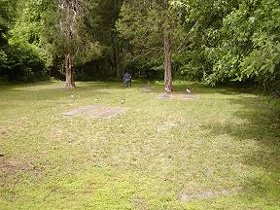 | 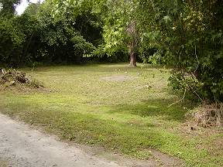
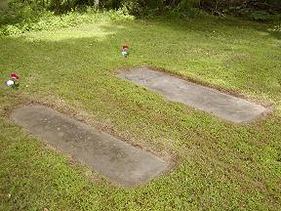 | 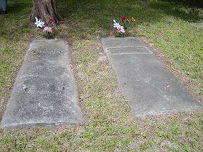
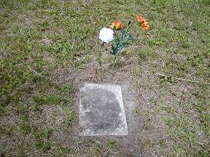 | 