Cofer ~Stallings Creek Dr~ Cemetery
Transcribed by members of the
Grave Site Survey Task Force (GSSTF)
Under the Auspices of
Isle of Wight County Historical Society (IWCHS)
Visited January 11, 2006

A selection of shaving foam, water, or talcum powder was used to improve the legibility of the inscriptions on the older tombstones. Afterwards, a clean water spray was used to remove any residue. GSSTF members were careful not to damage tombstones or artifacts during the transcription process.

Any text within the “[ ]” is a comment about the tombstone inscription, ex., [fs] indicates a footstone inscription. Throughout the transcribing process, an attempt was made to preserve the, ‘look and feel’ of the original inscriptions as regards word spacing, arrangement, and possible misspellings.

Please address your comments/corrections to: albert.b@charter.net or epowellsr@aol.com.

 | Inscription |  |  | Inscription
 | NANCY C. BATTEN  Wife of ELMO  Sept. 30, 1885  Nov. 13, 1968 |  |  | Father  JOHN R. COFER  Sept. 4, 1842,  June 20, 1886  J.R.C. [fs]
 | Mother  REBECCA A. COFER  April 23, 1846,  May 29, 1922.  R.A.C. [fs] |  |  | Son  RUSSELL C. COFER  Apr. 6, 1875  Oct. 28, 1955  R.C.C. [fs]
Note (1) | CHARLIE COFER  11 – 01 – 1971 |  | Note (1) | EVELYN B. COFER  04-09-1900  01-28-1953

Notes:
(1) The deceased was disinterred to either St. Lukes cemetery or to Mill Swamp cemetery, according to property owner.

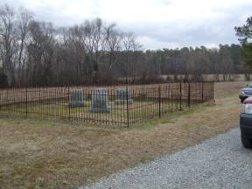 | 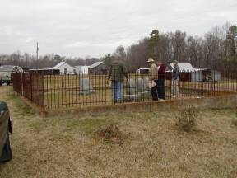
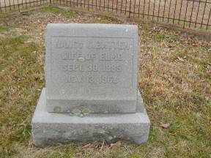 | 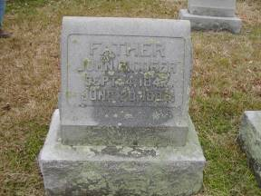
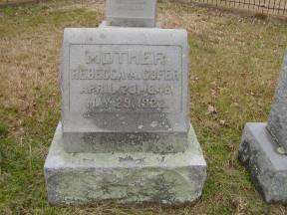 | 