Cofield ~Murphy Mill Rd~ Cemetery
Transcribed by members of the
Grave Site Survey Task Force (GSSTF)
Under the Auspices of
Isle of Wight County Historical Society (IWCHS)
Visited February 24, 2008

A selection of shaving foam, water, or talcum powder was used to improve the legibility of the inscriptions on the older tombstones. Afterwards, a clean water spray was used to remove any residue. GSSTF members were careful not to damage tombstones or artifacts during the transcription process.

Any text within the “[ ]” is a comment about the tombstone inscription, ex., [fs] indicates a footstone inscription. Throughout the transcribing process, an attempt was made to preserve the, ‘look and feel’ of the original inscriptions as regards word spacing, arrangement, and possible misspellings.

Please address your comments/corrections to: albert.b@charter.net or epowellsr@aol.com.

 | Inscription |  |  | Inscription
Note (1) | COFIELD  EMMETT W MARY M.  June 11, 1847 Jan 9, 1851  June 17, 1904 Aug 9 1919 |  |  | BESSIE  1905 – 1906
 | ELIZABETH COFIELD  May 10, 1883  Mar 23, 1908 |  |  | LIZZIE H. COFIELD  Oct 7 1876  May 12, 1948
 | VIRGINIUS W. COFIELD  Mar 22, 1870  Jan 19 1951 |  |  | Infant 1872
 | ESTELLE 1868 – 1874 |  |  | MAGGIE 1884 - 1889
 | Little HENRY 1855 – 1867 |  |  | Grandpa (MURPHY) 1797 – 1875
 | Grandma (MATHILDA MURPHY)  1822 – 1896 |  |  | PRUDEN  BETTY ELIZABETH MURPHY  1859 – 1882  Wife of  WILBER B. PRUDEN  1854 – 1935  B.E.P. [fs]
 | M. TURNER 1853 – 1882 |  |  | (PAYTON) P. MURPHY  1850 – 1894
 | PEYTON R. TURNER  Nov. 29, 1877  May 27, 1954 |  | Note (2)  Note (3) | In Loving Memory of  NETTIE B. wife of  J. J. COFIELD  [no date of birth or death]
Note (4) | HENRY S. COFIELD  Oct 10, 1878  Mar 4, 1925 |  |  | L. ATKINS  1911 – 1912
M. ATKINS
1910

Notes:
- Emmett W. Cofield is not buried in this cemetery – his remains are unknown. This monument erected by Hudson Cofield for his father & mother, Emmett & Mary.
- To the left of this tombstone is a footstone said to be Jasper J. Cofield … per Cofield descendant.
- To the right of this tombstone is an infant marker, name unknown.
- Brother of Jasper J. Cofield, son of Mary & Emmett Cofield.

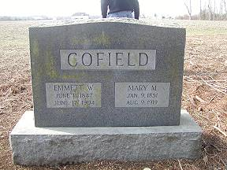 | 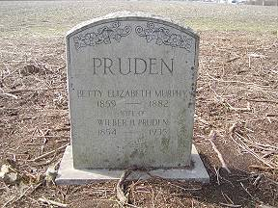
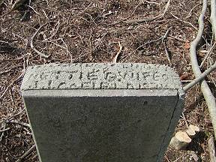 | 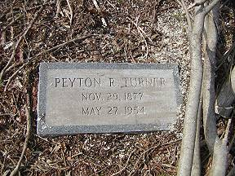
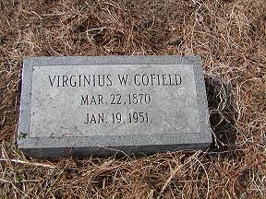 | 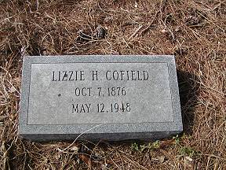
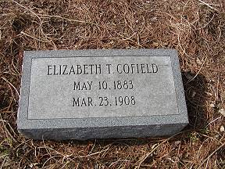 | 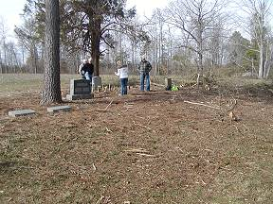
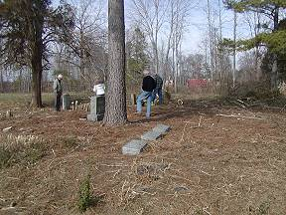 | 