Councill ~Collosse Rd~ Cemetery
Visited by Members of
Grave Site Survey Task Force (GSSTF)
Under the Auspices of
Isle of Wight County Historical Society (IWCHS)
February 5, 8, 2006

A selection of shaving foam, water, or talcum powder was used to improve the legibility of the inscriptions on the older tombstones. Afterwards, a clean water spray was used to remove any residue. GSSTF members were careful not to damage tombstones or artifacts during the transcription process.

Any text within the “[ ]” is a comment about the tombstone inscription, ex., [fs] indicates a footstone inscription. Throughout the transcribing process, an attempt was made to preserve the, ‘look and feel’ of the original inscriptions as regards word spacing, arrangement, and possible misspellings.

Please address your comments/corrections to: albert.b@charter.net or epowellsr@aol.com.

 | Inscription |  |  | Inscription
 | Thy will be done.  Blessed were the dead who died  In the Lord for they rest from their  Labours and their works do follow them.  MEDIA ANN  Wife of  JESSE D. COUNCILL,  and daughter of  WM & BARSHEBA KING;  of Nansemond County.  Died July 20, 1849,  Aged 23 yrs.  J D Couper  Norfolk. |  |  | C  Father  JESSE D. COUNCILL  Born  Feb. 11, 1820  Died  April 12, 1901  Aged  81 years, 2 months, & 1 day  Asleep in Jesus peaceful rest  Whose working is supremely blest.
 | Mother  ANTIONETTE J. COUNCILL  1834 – 1928  “He giveth his  beloved rest.” |  |  | ANNA P. COUNCILL  Sept. 15, 1848  Nov. 17, 1919  “She hath done what she  could.”  Mark XIV-VIII
 | JULIUS C. COUNCILL  son of  JOSEPH G & JUDITH COUNCILL  Died  July 4, 1854  Aged 23 years  ------------------  Cut off suddenly, but not  without hope. |  |  | BIRDIE P. COUNCILL  1869 - 1962
 | My home is in heaven  CHRISTIAN COUNCILL,  Daughter of  GODWIN & PHERABY  COUNCILL;  Died Sep. 29, 1855  Aged 17 yrs. |  |  | JUDITH YEATES  Wife of  JOSEPH G. COUNCILL  And daughter of  ELIJAH & MARY McCLENNY  of Nansemond County,  Born March 5th 1802  Died April 24, 1839.

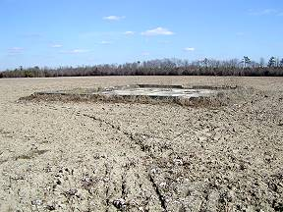 | 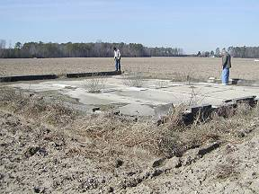
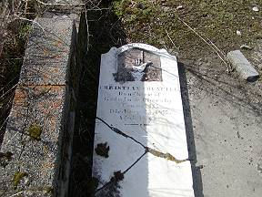 | 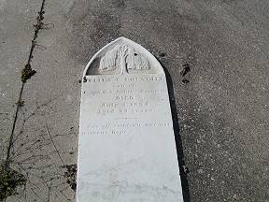
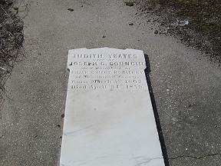 | 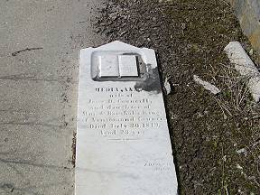
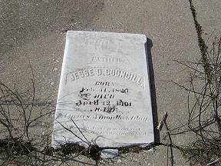 | 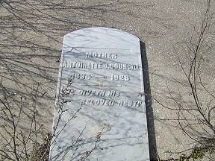
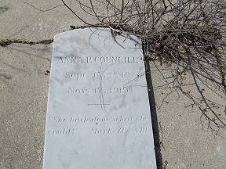 | 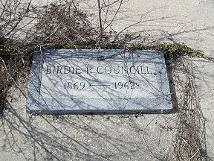
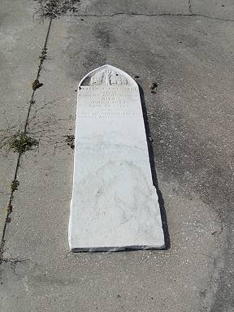 | 