Crocker ~Modest Neck Rd~ Cemetery
Transcribed by members of the
Grave Site Survey Task Force (GSSTF)
Under the Auspices of
Isle of Wight County Historical Society (IWCHS)
Visited March 26, 2006

This small, well-maintained cemetery is located in the rear of a private residence on Modest Neck Road … an iron railing fence in good condition surrounds it.

Any text within the “[ ]” is a comment about the tombstone inscription, ex., [fs] indicates a footstone inscription. Throughout the transcribing process, an attempt was made to preserve the, ‘look and feel’ of the original inscriptions as regards word spacing, arrangement, and possible misspellings.

Please address your comments/corrections to: albert.b@charter.net or epowellsr@aol.com.

 | Inscription |  |  | Inscription
 | J. WILLIAM CROCKER  May 26, 1865  Aug. 9, 1943 |  |  | ANNIE S. CROCKER  Nov 18, 1895  Oct 18, 1983
 | WILLIAM SALLIE  CROCKER CROCKER  Sept 15, 1827 Nov. 12, 1832  May 5, 1894 Jan. 25, 1907  CROCKER  W.C. [fs] S.C. [fs] |  |  | KATIE SADLER GRAY  Dec. 19, 1901  Mar. 21, 1988
MARGARET
CROCKER
July 15, 1855
May 29, 1923

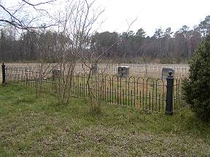 | 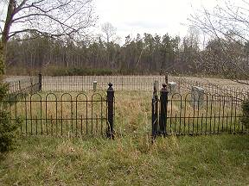
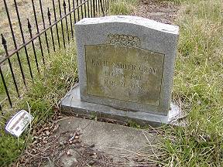 | 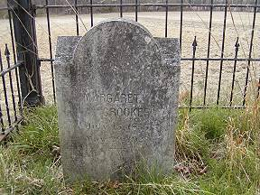
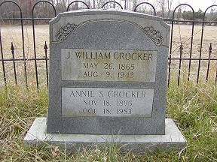 | 