Cutchin ~Wash Hole Rd~ Cemetery
Transcribed by members of the
Grave Site Survey Task Force (GSSTF)
Under the Auspices of
Isle of Wight County Historical Society (IWCHS)
Visited February 12, 2006

This small cemetery is located in a farm field at the end of Wash Hole Road and concrete pillars have been installed around the periphery to protect the tombstones and help define the cemetery. GSSTF members were careful not to damage tombstones or artifacts during the transcription process.

Any text within the “[ ]” is a comment about the tombstone inscription, ex., [fs] indicates a footstone inscription. Throughout the transcribing process, an attempt was made to preserve the, ‘look and feel’ of the original inscriptions as regards word spacing, arrangement, and possible misspellings.

Please address your comments/corrections to: albert.b@charter.net or epowellsr@aol.com.

 | Inscription |  |  | Inscription
 | BARBARA ASHBURN CUTCHIN  Married: Feb. 17, 1868  Died: Feb. 13, 1872  Wife of JOSEPH J. CUTCHIN |  |  | Pvt  JOSEPH J CUTCHIN  CO K  24 VA CAV  CSA  Jan 25 1830  Nov 23 1899
JEMINA ASHBURN CUTCHIN
Married: Mar 5 1873
Died: Dec. 13, 1887
Wife of JOSEPH J. CUTCHIN

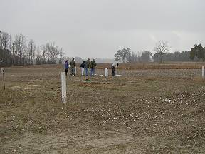 | 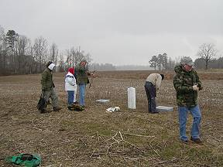
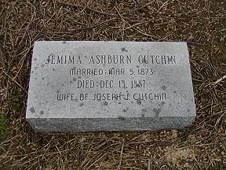 | 