Daniel ~Cedar Grove Rd~ Cemetery
Visited by Members of the Grave Site Survey Task Force (GSSTF)
Under the Auspices of Isle of Wight County Historical Society (IWCHS)
October 17, 2004

This small cemetery is located off of Carrollton Blvd (# 17) on private property … the property owner discovered the cemetery in heavy underbrush after the property was purchased. He has maintained the surrounding area in good condition. The property owner also stated that there was evidence of other graves in the area, noted by depressions in the ground, although no visible stones or other markings were found.

A selection of shaving foam, water, or talcum powder was used to improve the legibility of the inscriptions on the older tombstones. Afterwards, a clean water spray was used to remove any residue. SSTF members were careful not to damage tombstones or artifacts during the transcription process.

Please address your comments/corrections to: albert.b@charter.net or epowellsr@aol.com.

 | Inscription |  |  | Inscription
 | ROBERT T. DANIEL  Nov. 9, 1833  June 9, 1906  “Gone but not forgotten” |  | Note (1) | CARNELIAN F. DANIEL  Dec. 4, 1844  MCH 23, 1920  “Gone but not forgotten”
Note (1) | GEORGE F. DANIEL  Nov. 12, 1875  Mch. 7, 1908  “Gone but not forgotten” |  |  | To. My Mother  SARAH B. FOSTER  Born Dec 31, 1804  Died July 26, 1875  “Blessed are the dead  which die in the Lord that  they may rest from their  labors; and their work do follow them”

NOTES:
(1) The word, “Mch” or, “MCH” is not an error in spelling … it is actually engraved on the tombstone and is obviously an abbreviation for “March”.

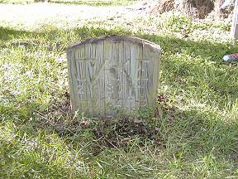 | The picture to the left  is evidently the  burial site of a family pet …

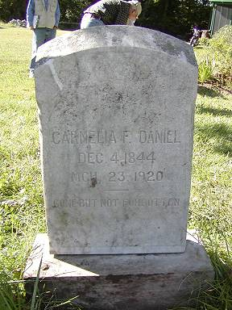 | 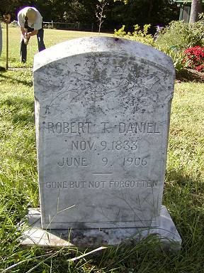
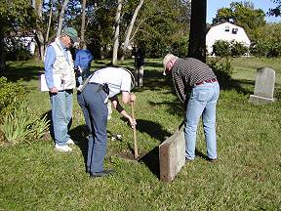 | 