Darden-Joyners Bridge Rd-Cemetery
Transcribed by members of the
Grave Site Survey Task Force (GSSTF)
Under the Auspices of
Isle of Wight County Historical Society (IWCHS)
Visited October 4, 2013

This small cemetery is located in a farm field behind and beside a private residence at 5236 Joyners Bridge Rd. There were no visible born/died dates on any of the tombstones.

Please address your comments/corrections to: albert.b@charter.net or epowellsr@aol.com.

 | Inscription |  |  | Inscription
 | DARDEN  d. H. |  |  | DAVID  DARDEN
POLLY
DARDEN

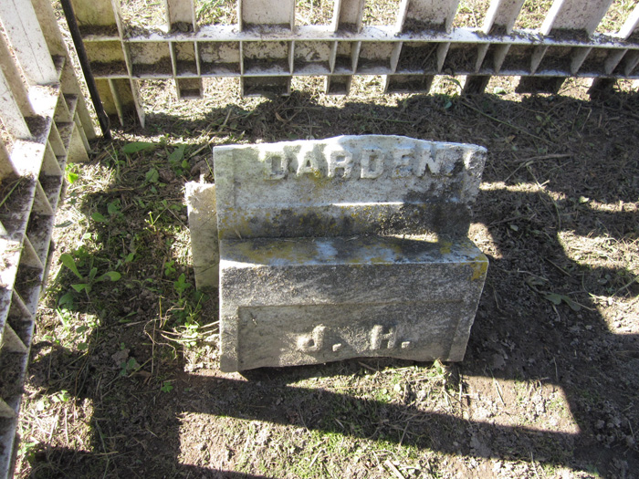 | 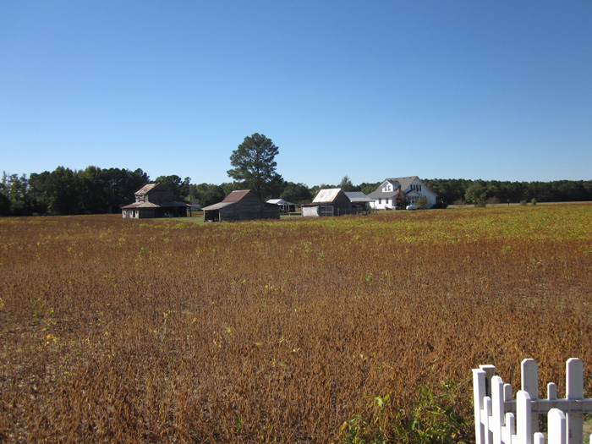
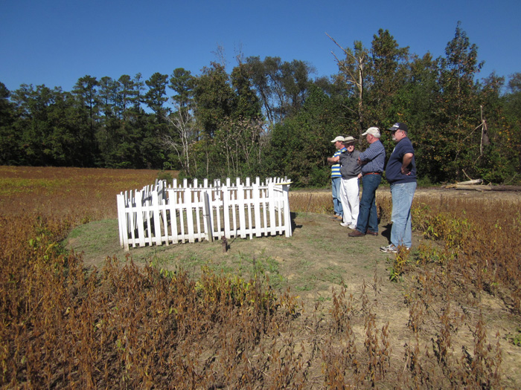 | 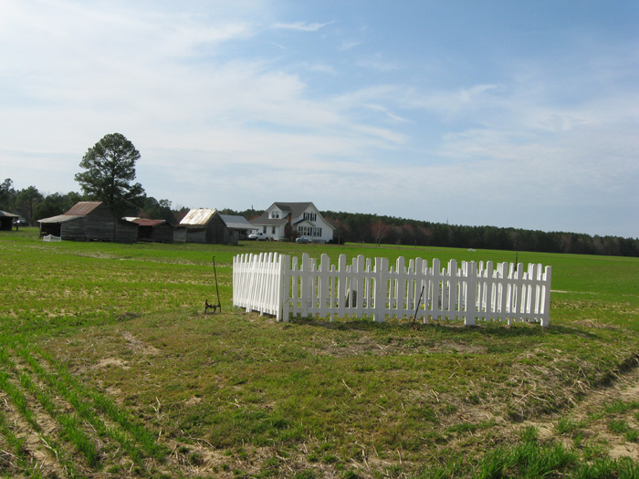
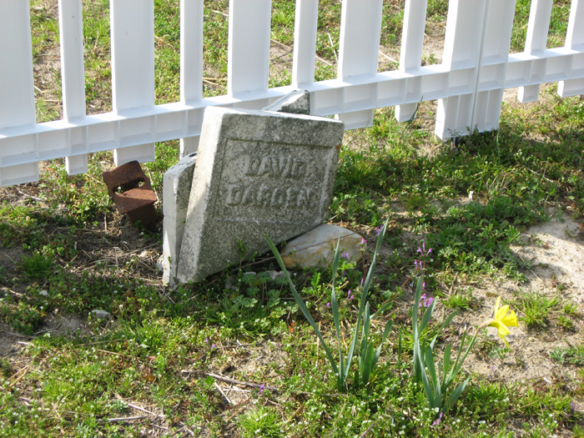 | 