DARDEN ~Orbit Rd (No 2)~ Cemetery
Visited by Members of
Grave Site Survey Task Force (GSSTF)
Under the Auspices of
Isle of Wight County Historical Society (IWCHS)

April 25, 2004

This is the second of Darden Cemeteries located on Orbit Road that have been transcribed by the GSSTF. It is located behind an old farmhouse about 1-1/2 miles east of hwy # 258. There are only two tombstones visible and a rather elaborate ironwork fence surrounds the cemetery, as depicted in the pictures below.

Any text within the “[ ]” is a comment about the tombstone inscription, ex., [fs] indicates a footstone inscription. Throughout the transcribing process, an attempt was made to preserve the, ‘look and feel’ of the original inscriptions as regards word spacing, arrangement, and possible misspellings.

Please address your comments/corrections to: albert.b@charter.net or epowellsr@aol.com.

 | Inscription |  |  | Inscription
 | CHAS. H.  DARDEN  Born  Sept. 10, 1822  Died  Apr. 21, 1878  “Erected by his Son”  J. M. DARDEN  C.H.D. [fs] |  |  | In Memory of  A. F. DARDEN  Born Jan. 6, 1817  Died Aug. 18, 1863  “Erected by his Wife”  A.F.D. [fs]

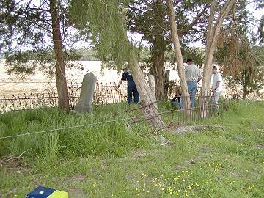 | 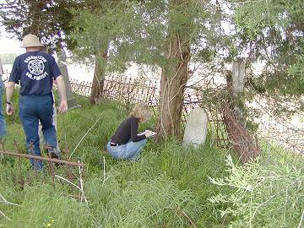
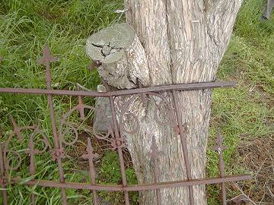 | 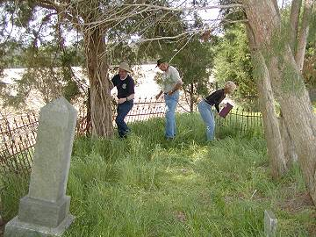
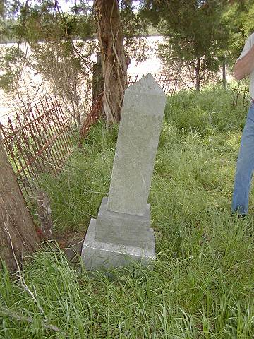 | 