DARDEN ~Bob White Rd~ Cemetery

Visited by Members and Volunteers of
Isle of Wight County Historical Society

January 7, 2004
The cemetery is located in a front field just off of Bob White Rd on the farm of John R. Darden. It is heavily overgrown with briars, weeds, and a fallen tree that was toppled by hurricane Isabel. Figures 1 – 2 show views of the cemetery taken from the field next to Bob White Rd. Figure 3 has an interesting story; an employee of the old Darden farm, Alius Edwards, expressed his desire to be buried somewhere on the property … as a result, he was buried in a separate fenced area in a corner of the main cemetery. The following is a direct quote from the Southampton County Historical Society records: “*In a brick vault, unmarked and outside but adjacent to the family cemetery, is buried Alius Edwards, brother of Dick Edwards. He had worked for J.R. Darden's father as a farm laborer. He had requested that he be buried outside but adjacent to the family cemetery.”
Team members were careful not to disturb artifacts or cause damage to the tombstones. A combination of shaving cream and water was used to clean and improve the legibility of the tombstone inscriptions. Afterwards, a water spray was used to remove any residue.
Please address your comments/corrections to: albert.b@charter.net or epowellsr@aol.com.

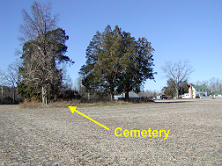 | 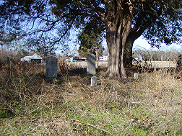

Photo ID # | Inscription |  | Photo ID # | Inscription
1  Note (1)  Note (2) | JOHN PHILLIPS  Born  Jany 6, 1800,  Died  March 11, 1842  J.P. [fs] |  | 2  Note (2) | ELIZABETH PHILLIPS  Born  Jany 15, 1798  Died  March 1866  E.P. [fs]
3 | ELIZABETH WILSON  Born  Nov. 6, 1828  Died  Dec. 1884  E.W. [fs] |  | 4 | WILLIAM JOSIAH II WILSON  Born  Nov. 24, 1818  Died 1868  W.J.W. [fs]
5 | EDWARD H. DARDEN  Born  1824  Died June 31, 1878  E.H.D. [fs] |  | 6 | MARVA DARDEN  Born  July 15, 1836  Died  Dec. 15, 1897
7 | MAGGIE  Daughter of  JOHN & LAURA  DARDEN  Born  Sept. 14, 1885  Died  Oct. 13, 1886 |  | 8  Note (3) | JOHNNIE  Son of  JOHN & LAURA  DARDEN  Born  Feb. 12, 1893  Died  June 23, 1893  [fs]
9 | In Memory Of  LAURA J.  DARDEN  Born  Oct. 12, 1864  Died  April 14, 1907  L.J.D. [fs] |  | 10 | In Memory Of  My Dear Husband  J. R. DARDEN  Sept. 14, 1858  Feb. 2, 1934  “At Rest”  J.R.D. [fs]
11 | In Memory Of  GEORGE W.  DARDEN  Born  Nov. 17, 1889  Died  May 13, 1907  G.W.D. [fs]

NOTES:
- Any text between the, “[“ and “]” is for clarification purposes and is not inscribed on the stones, ex, [fs] indicates that the inscription is on a footstone.
- The abbreviation of, “January” as “Jany” is not an error in transcription … that is exactly what is inscribed on the tombstone.
- Has a footstone but no inscription was visible.

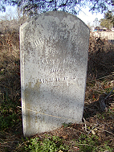 | 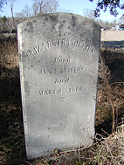 |  | 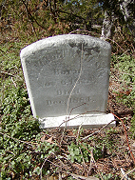
1 | 2 |  | 3
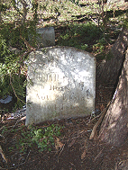 | 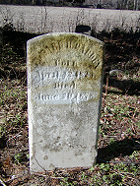 |  | 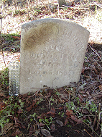
4 | 5 |  | 6
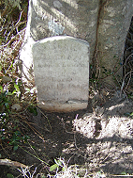 | 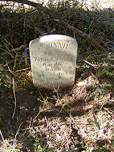 |  | 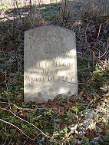
7 | 8 |  | 9
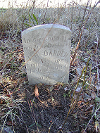 | 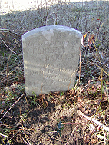 |  | 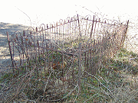  Figure 3
10 | 11
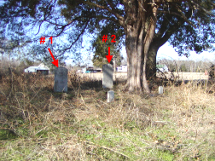 |  | 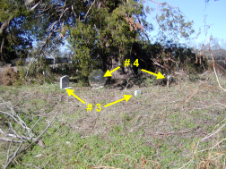
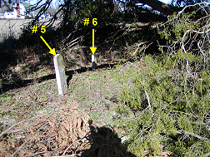 |  | 