Daughtrey ~Glen Haven Rd~ Cemetery
Transcribed by members of the
Grave Site Survey Task Force (GSSTF)
Under the Auspices of
Isle of Wight County Historical Society (IWCHS)
Visited April 2, 2006

A selection of shaving foam, water, or talcum powder was used to improve the legibility of the inscriptions on the older tombstones. Afterwards, a clean water spray was used to remove any residue. GSSTF members were careful not to damage tombstones or artifacts during the transcription process.

Any text within the “[ ]” is a comment about the tombstone inscription, ex., [fs] indicates a footstone inscription. Throughout the transcribing process, an attempt was made to preserve the, ‘look and feel’ of the original inscriptions as regards word spacing, arrangement, and possible misspellings.

Please address your comments/corrections to: albert.b@charter.net or epowellsr@aol.com.

 | Inscription |  |  | Inscription
 | SHIRLEY GRANT  Born Nov 6, 1907  Died Aug 11, 1956 |  |  | JOAN C. GRANT  Feb 15, 1948  April 14, 1967
 | MARY B. MURPHY  April 28, 1924  May 11, 1967 |  |  | GEORGE BARNES  Virginia  Pvt CO C  511 Engineers  World War I  March 11 1895  November 15 1942
 | WILLIE R MADDREY  Born Jan 2, 1879  Died July 7, 1953 |  |  | LUCY ANN MADDREY  Born Sept, 18, [year illegible]  Died Dec. 20, 1958
 | ROSCOE MADDREY  Born Feb 10, 1907  Died Oct 28, 1958 |  |  | ROBERT TURNER  Born May 11, 1885  Died Apr 10, 1948
 | PRESTON TURNER  Died Jan 12, 1948  Age 29 year |  |  | [unmarked grave]
 | CATHERINE DAUGHTREY  Born  Oct. 9, 1832  Died  Aug. 1, 1902 |  |  | BENJAMIN DAUGHTREY  Died  Nov. 27, 1905  Age 87 yrs
 | [3 unmarked graves] |  |  | ANNIE G.  Oct 14 1897  May 23 1898  DAUGHTREY  IDONIA  Sep 19 1902  Aug 15 1906  Asleep in Jesus
 | [unmarked vault] |  |  | [unmarked vault]
 | TEXIE DAUGHTREY  Born May 20, 1889  Died May 12, 1959  Age 70 years |  |  | PAUL DAUGHTREY  Died Oct 14, 1947
 | [unmarked grave] |  |  | EVA TURNER  Died Oct 13, 1943  Age 52
 | JACK HOLLAND  Aug. 22, 1897  June 14, 1992 |  |  | KENNEY HOLLAND  Nov 15 1905  Nov 12 1982
 | DAVID DAUGHTREY  Died June 17, 1960 |  |  | [unmarked grave]
 | [unmarked vault] |  |  | REBECCA HOLLAND  Jan 18, 1897  Oct 18, 1987
 | NANCY HOLLAND  July 15, 1897  Nov 29, 1968 |  |  | THOMAS DAUGHTREY  born – 1871  Died – 1947
 | [unmarked grave] |  |  | EDWARD LEE ASHE  Sept. 14, 1936  July 4, 1976
 | [2 unmarked graves] |  |  | SAMUEL G HOLLAND  Nov 18, 1947  Oct 21, 1992
Mrs. BESSIE E. PORTER
Born June 11, 1918
Died Sept. 17, 1956

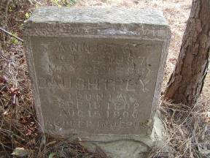 | 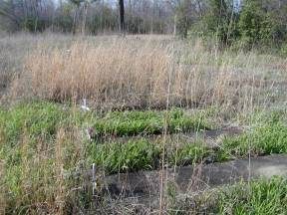
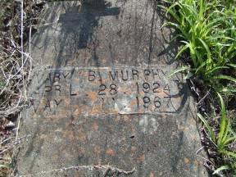 | 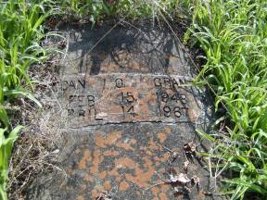
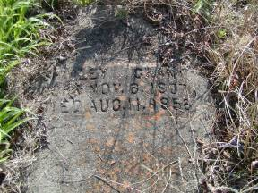 | 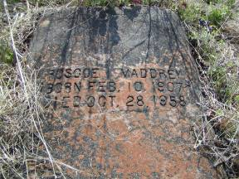
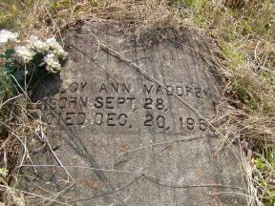 | 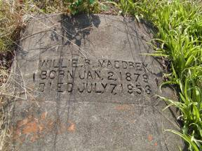
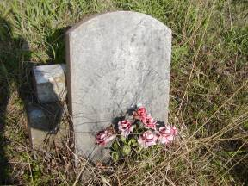 | 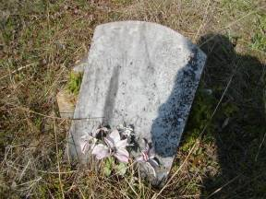
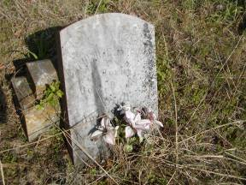 | 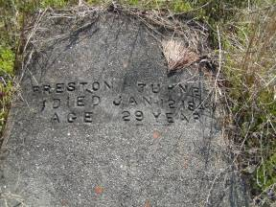
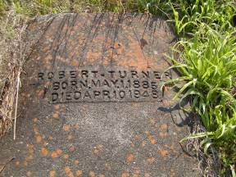 | 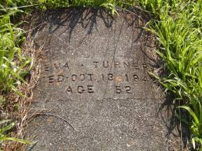
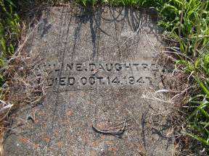 | 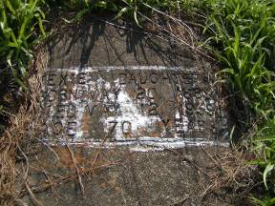
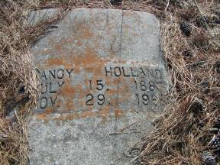 | 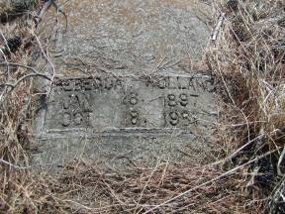
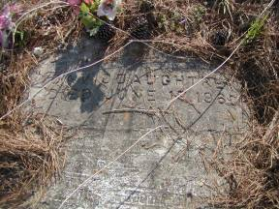 | 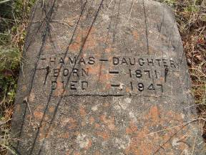
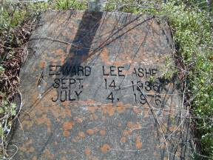 | 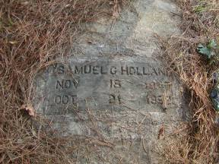
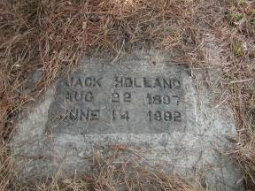 | 