Davis ~Field of Dreams Lane~ Cemetery
Transcribed by members of the
Grave Site Survey Task Force (GSSTF)
Under the Auspices of
Isle of Wight County Historical Society (IWCHS)
Visited March 12, 2006

This small, secluded cemetery located off of Courthouse Hwy (# 258) on a gravel road that is not yet officially named, although the property owner has hope that the official name will be that listed above. It is located in the woods amidst heavy undergrowth and covered with debris. Its location would have been difficult, if not impossible, were it not for the assistance of the property owner who had discovered it while walking through the woods.

GSSTF members were careful not to damage tombstones or artifacts during the transcription process.

Any text within the “[ ]” is a comment about the tombstone inscription, ex., [fs] indicates a footstone inscription. Throughout the transcribing process, an attempt was made to preserve the, ‘look and feel’ of the original inscriptions as regards word spacing, arrangement, and possible misspellings.

Please address your comments/corrections to: albert.b@charter.net or epowellsr@aol.com.

 | Inscription |  |  | Inscription
 | IRENE SUMMERSETT  Died July 17 1966 |  |  | [concrete slab – no inscriptions]
 | MARGARET F. BOOTHE  died July 31 1991  Aged 36 years  M.F.B. [fs] |  |  | CARRIE L. DAVIS  Born Feb 25 1886  died Apr 28 1899  Gone but not forgotten
 | AMY L. DAVIS  died July 2  1933 |  |  | W. H. DAVIS  born  May 20, 1860  died  Mar 10, 1912  W.H.D. [fs]
 | [numerous depressions in ground, indicating other graves – also a marble slab with no inscriptions visible]

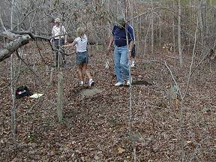 | 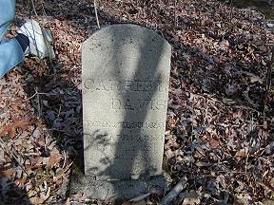
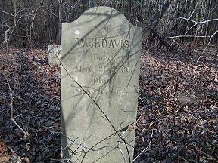 | 