Duck ~Holly Run Tr~ Cemetery
Transcribed by members of the
Grave Site Survey Task Force (GSSTF)
Under the Auspices of
Isle of Wight County Historical Society (IWCHS) – http://www.iwchs.com/
Visited August 24, 2005

This small, well-maintained cemetery is located behind the residence of Mr. William M. Camp on Holly Run Trail. GSSTF members wish to acknowledge and thank Mr. Camp and Ms. Anne Vincent for their cooperation and assistance during the visit.

A selection of shaving foam, water, or talcum powder was used to improve the legibility of the inscriptions on the older tombstones. Afterwards, a clean water spray was used to remove any residue. GSSTF members were careful not to damage tombstones or artifacts during the transcription process.

Any text within the “[ ]” is a comment about the tombstone inscription, ex., [fs] indicates a footstone inscription. Throughout the transcribing process, an attempt was made to preserve the, ‘look and feel’ of the original inscriptions as regards word spacing, arrangement, and possible misspellings.

Please address your comments/corrections to: albert.b@charter.net or epowellsr@aol.com.

 | Inscription |  |  | Inscription
 | NANCY B. DUCK  Born  Feb. 26, 1793  Died  Aug. 1875  N.B.D. [fs] |  |  | JACOB H. DUCK  Born  Nov. 24, 1793  Died  Mar. 23, 1863  J.H.D. [fs]

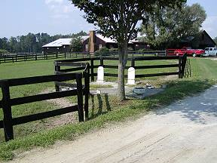 | 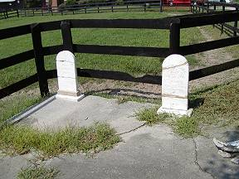
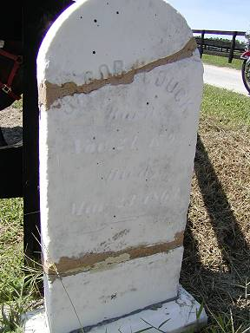 | 