Duck ~Wood Duck Dr~ Cemetery
Transcribed by members of the
Grave Site Survey Task Force (GSSTF)
Under the Auspices of
Isle of Wight County Historical Society (IWCHS)
Visited January 11, 2006

A selection of shaving foam, water, or talcum powder was used to improve the legibility of the inscriptions on the older tombstones. Afterwards, a clean water spray was used to remove any residue. GSSTF members were careful not to damage tombstones or artifacts during the transcription process.

Any text within the “[ ]” is a comment about the tombstone inscription, ex., [fs] indicates a footstone inscription. Throughout the transcribing process, an attempt was made to preserve the, ‘look and feel’ of the original inscriptions as regards word spacing, arrangement, and possible misspellings.

Please address your comments/corrections to: albert.b@charter.net or epowellsr@aol.com.

 | Inscription |  |  | Inscription
 | Father  JOHN BRYANT DUCK  Aug. 13, 1900  June 4, 1985 |  |  | Mother  HATTIE MAE ROSE DUCK  July 28, 1907  Mar. 22, 1932
Note (1) | ----- AY – R—DUCK  - 194—  1909  Purvance Funeral Home |  |  | MAMIE DUCK  WILKINS  1886 – 1957
 | ELLIE BLYTHE DUCK  1888 – 1979 |  |  | BURGESS S. DUCK  Virginia  Pvt Co A 317 Infantry  World War I PH  Nov 10 1891 – March 17 1964
 | THOMAS R. DUCK  Nov. 25, 1877  May 16, 1929  T.R.D. [fs] |  |  | DUCK  MILLS H. DUCK MARY R. J. DUCK  Nov. 27, 1852 Jan 11, 1862  Feb. 29, 1920 Dec. 6, 1948  Gone but not Gone but not  forgotten forgotten  M.H.D. [fs]

Notes:
(1) The hyphens “—“ indicate illegible characters engraved on the stone or funeral home marker.

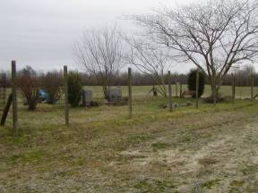 | 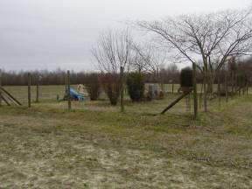
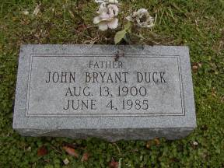 | 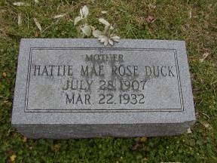
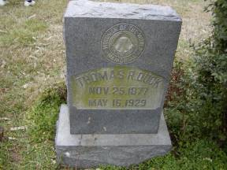 | 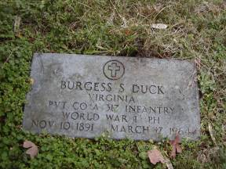
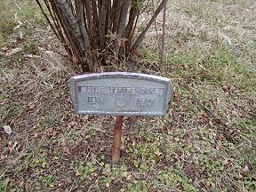 | 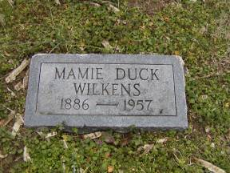
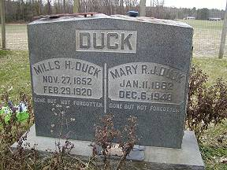 | 