Edwards ~Emmanuel Church Rd~ Cemetery
Transcribed by members of the
Grave Site Survey Task Force (GSSTF)
Under the Auspices of
Isle of Wight County Historical Society (IWCHS)
Visited July 17, 2005

This small cemetery is located in the woods behind a private residence at 10201 Emmanuel Church Road. It is surrounded by a chain link fence and is about 100 feet square. Most of the tombstones are in good condition with the exception of a few that have been broken. As is customary in the transcribing/report preparation process, if no official name is known for the cemetery, the cemetery name is derived from the last name of the majority deceased.

A selection of shaving foam, water, or talcum powder was used to improve the legibility of the inscriptions on the older tombstones. Afterwards, a clean water spray was used to remove any residue. GSSTF members were careful not to damage tombstones or artifacts during the transcription process.

Any text within the “[ ]” is a comment about the tombstone inscription, ex., [fs] indicates a footstone inscription. Throughout the transcribing process, an attempt was made to preserve the, ‘look and feel’ of the original inscriptions as regards word spacing, arrangement, and possible misspellings.

Please address your comments/corrections to: albert.b@charter.net or epowellsr@aol.com.

 | Inscription |  |  | Inscription
 | ALMEDIA R.  Wife of  WILLIAM J. ELLIS  Born Dec. 15, 1825  Died Jan. 1, 1904  Honored beloved  and wept  Here Mother lies |  | Note (1) | WILLIAM J. ELLIS  Born June 15, 1823  May the resurrection  find thee on the  bosom of they God
 | MALLISSA  Daughter of  WILLIAM J. & AMELIA  R. ELLIS  Born May 26, 1854  Died Apr. 11, 1892  Gone to a brighter  home  Where grief cannot  come |  |  | WALTER L.  Son of  BENJAMIN K. &  HENRIETTA  EDWARDS  Born May 31, 1891  Died Aug 27, 1891  Asleep in  Jesus
Note (2) | WILLIAM B.  Son of  BENJAMIN K. &  HENRIETTA EDWARDS  Born Sep. 28, 1871  Died Mar. 2, 1901  Though thou art  gone  Fond memry clings  to thee |  |  | Sister  MARTHA H. EDWARDS  April 5, 1917  June 27, 1917
 | Brother  WILLIAM B. EDWARDS  June 24, 1910  Jan. 20, 1916 |  |  | ANNIE B C  wife of  J. H. EDWARDS  Born June 8, 1883  Died May 18, 1913  May the resurrect  -tion find thee  on the bosom of  thy God
 | JOHN M.  son of  J. H. & ANNIE B  C. EDWARDS  Born May 15, 1910  Died July 16, 1910  Gone but not  forgotten |  |  | F. L. GWALTNEY  Born  March 2[illegible], 1844  Died  Dec. 26, 1888
 | ALONZO  son of  WILLIAM J. & AMELIA  R. ELLIS,  Born Oct. 26, 1849  Died Nov. 20, 1871  Thy memory shall  ever be  A guiding star to  Heaven |  |  | BENJAMIN T.  son of  WILLIAM J. & AMELIA  R. ELLIS  Born Dec. 2[illegible], 1851  Died July 31, 1879  May the resurrection  find thee  on the bosom of thy God
 | Mother  HENRIETTA M. ELLIS  wife of  BENJAMIN K. EDWARDS  Born Mar. 10, 1848  Died Aug. 8, 1928  Asleep in Jesus |  |  |   BENJAMIN K. EDWARDS  Born Aug. 7, 1838  Died June 26, 1913  “O death where is thy sting?”  “O grave; where is thy victory?”
ANGELINA C.
EDWARDS
Born May 9, 1835
Died Mar. 23, 1906
Thy memory shall
ever be
A guiding star to
Heaven

Notes:
(1) The word, “they” is inscribed on the tombstone … one would think that, “thy” would be appropriate.
(2) The word, “memry” is actually engraved on the tombstone, not a typo.

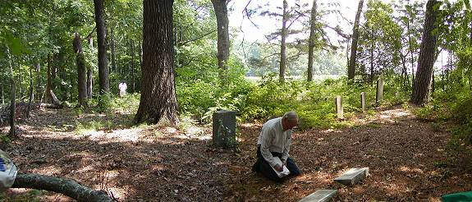


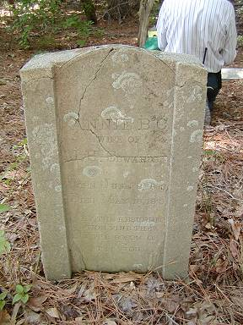 | 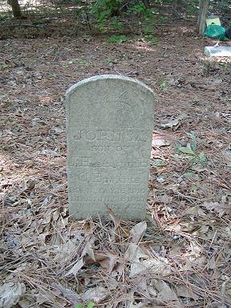
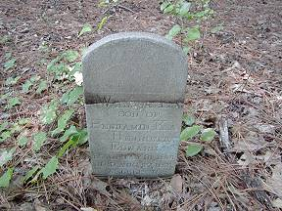 | 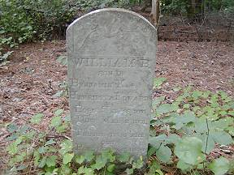
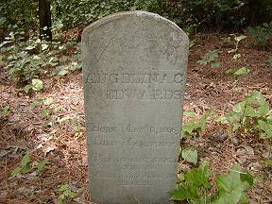 | 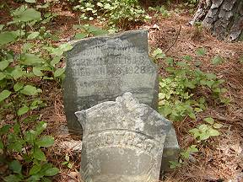
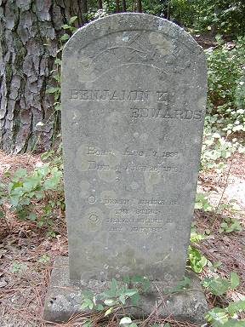 | 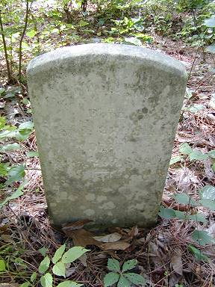
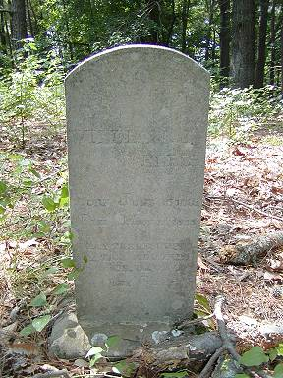 | 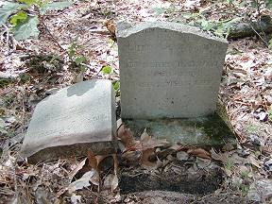
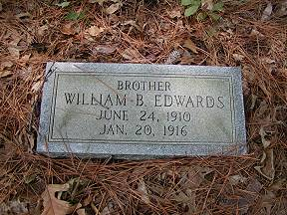 | 