Eley ~See-Gaw Rd~ Cemetery
Transcribed by members of the
Grave Site Survey Task Force (GSSTF)
Under the Auspices of
Isle of Wight County Historical Society (IWCHS)
Visited August 30, 2005

There is evidence that other persons are buried in this small cemetery located in a farmer’s field in Carrsville … two other tombstones are on the ground although there are no visible markings on them.

A selection of shaving foam, water, or talcum powder was used to improve the legibility of the inscriptions on the older tombstone. Afterwards, a clean water spray was used to remove any residue. GSSTF members were careful not to damage tombstones or artifacts during the transcription process.

Throughout the transcribing process, an attempt was made to preserve the, ‘look and feel’ of the original inscriptions as regards word spacing, arrangement, and possible misspellings.

PERMELIA
Wife of
BENJAMIN ELEY
died
July 1st 1861
Age 51 years
Gone but not lost
A faithful companion and Mother
and sincere Christian

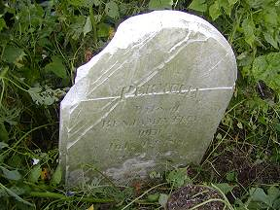 | 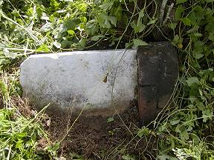
 | Blank stone fallen on side
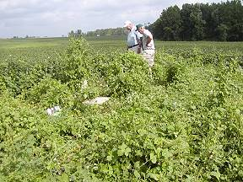 | 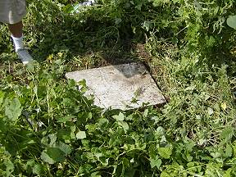
 | Blank stone
Please address your comments/corrections to: albert.b@charter.net or epowellsr@aol.com.

