Ellis ~Bethany Church Rd~ Cemetery
Transcribed by members of the
Grave Site Survey Task Force (GSSTF)
Under the Auspices of
Isle of Wight County Historical Society (IWCHS)
Visited April 30, 2006

A selection of shaving foam, water, or talcum powder was used to improve the legibility of the inscriptions on the older tombstones. Afterwards, a clean water spray was used to remove any residue. GSSTF members were careful not to damage tombstones or artifacts during the transcription process.

Any text within the “[ ]” is a comment about the tombstone inscription, ex., [fs] indicates a footstone inscription. Throughout the transcribing process, an attempt was made to preserve the, ‘look and feel’ of the original inscriptions as regards word spacing, arrangement, and possible misspellings.

Please address your comments/corrections to: albert.b@charter.net or epowellsr@aol.com.

 |  | Inscription |  |  |  | Inscription
 |  | JUNIOUS ELLIS  Born  Sept. 25, 1846  died  Apr. 12, 1911  Gone but not forgotten  J.E. [fs] |  |  |  | CHAPMAN E. ELLIS  born  Oct 17, 1866  died  Oct 17, 1890  At rest  C.E.E. [fs]
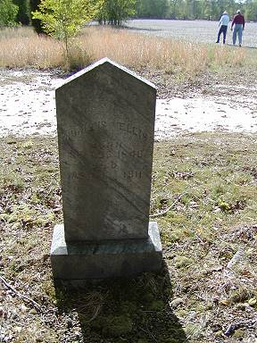 |  |  |  |  | 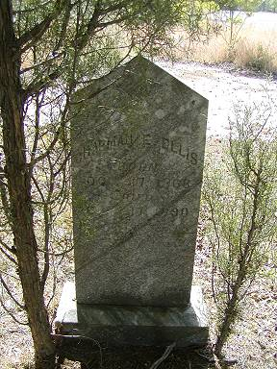
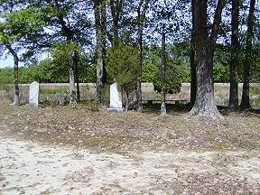 |  |  |  |  | 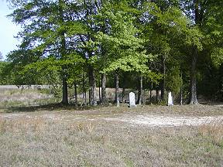
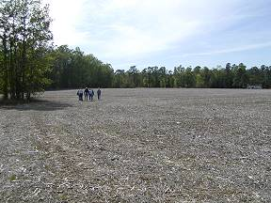 |  |  |  |  | 