ENSLEY ~ Sugar Hill Rd~ Cemetery

Visited by Members & Volunteers of
Isle of Wight County Historical Society
January 4, 2004

Ensley Cemetery is located next to Oak Grove United Methodist Church on Sugar Hill Road in Carrollton. There were only four visible graves with tombstones. Figure 1 shows a view of the small cemetery looking in from near the road. Although damage from hurricane Isabel was evident in the surrounding areas, the burial grounds were not disturbed.

Please address your comments/corrections to: albert.b@charter.net or epowellsr@aol.com.

Photo No. | Inscription |  | Photo No. | Inscription
1 | CYRUS J. ENSLEY  1855 --- 1932  SUSIE D. ENSLEY  1863 – 1910 |  | 2 | WADE M. ENSLEY  Virginia  SGT CO B  41 BN US Guards  World War I  March 24 1894  May 28, 1956
3 | HILDREY ENSLEY  1901 – 1971

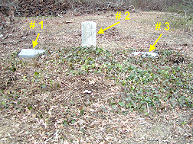 | 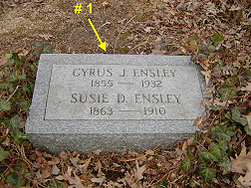
Figure 1 | Figure 2
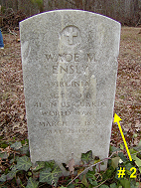 | 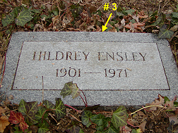
Figure 3 | Figure 4

