Evergreen ~Cedar St~ Cemetery
Visited by Members of
Grave Site Survey Task Force (GSSTF)
Under the Auspices of
Isle of Wight County Historical Society (IWCHS)
August 18, 2004

A selection of shaving foam, water, or talcum powder was used to improve the legibility of the inscriptions on the older tombstones. Afterwards, a clean water spray was used to remove any residue. GSSTF members were careful not to damage tombstones or artifacts during the transcription process.

Any text within the “[ ]” is a comment about the tombstone inscription, ex., [fs] indicates a footstone inscription. Throughout the transcribing process, an attempt was made to preserve the, ‘look and feel’ of the original inscriptions as regards word spacing, arrangement, and possible misspellings.

Please address your comments/corrections to: albert.b@charter.net or epowellsr@aol.com.

 | Inscription |  |  | Inscription
 | MARY M. HILLYER  May 2, 1867  July 2, 1887 |  |  | To the memory of  Our Mother  SARAH PARKER  Born  Sept. 28, 1826  Died  May 25, 1891  “She hath done  What she could”  S.P. [fs]
 | R. H. PARKER  Born  Sept. 1, 1851  Died  Feb. 7, 1910 |  |  | Sacre’ a Le memoire de  STELLA MAY EDWARDS  Born  Jan. 1, 1868  Died  May 1, 1886  “Asleep in Jesus blessed sleep  Poor unbelievers of a stormy day,  From wave to wave we’re driven,  And fancy’s flash and reason’s ray  Serve but to light our troubled way.  There’s nothing bright but Heaven.”  S.M.E. [fs]
 | CATHERINE EDWARDS  Died 1889  Aged 67 years  C.E. [fs] |  |  | RICHARD H. EDWARDS  Died 1900  Aged 30 years  R.H.E. [fs]
 | JOHN T. PURVIS  Born  Sept. 22, 1850,  Died  Feby. 2, 1909  J.T.P. [fs] |  |  | SARAH R.  Wife of  JOHN T. PURVIS  Born Dec. 1850  Died June 15, 1916  S.R.P. [fs]
 | OLIVIA PURVIS  Born  Dec. 1878.  Died  May 1879, |  |  | ROBERT FRANKLIN  PURVIS.  Born Aug. 1882,  Died Feby. 1883.
 | IRA A. son of  J. A. & E. J.  WHITE  Born & Died  Dec. 11, 1895  I.A.W. [fs] |  |  | In memory of  MARGARET E.  Wife of  J. A. BROWN  Died Oct. 8, 1900  Aged 65  “Rest in Peace”
 | In memory of  JAMES ALBERT BROWN  Born Aug. 13, 1846  Departed this life  Sept. 11, 1916  “Love my God and my friends” |  |  | IDA MAY BROWN  Born  Died  [stone broken – indecipherable]  1917
 | Pvt  JAMES ALBERT BROWN  CO D  16 Regt  VA Inf  CSA  Aug 13 1846  Sep 11 1916 |  |  | JAMES ALLEN JOHNSON  Co. E 9th VA Inf  CSA  J.A.J. [fs]
 | In memory of our Darling  EDYTHE ELAINE KINE  Born March 19, 1898  Died Oct. 29, 1901 |  |  | ALEXANDER LIBBY  Born Warren, Maine  Oct. 10, 1815  Died Isle Wight Co. VA.  Oct. 18, 1893  A.L. [fs]
 | MARGARET W. LIBBY  Born Warren, ME.  Sept. 12, 1819  Died Isle Wight Co. VA.  July 15, 1900  M.W.L. [fs] |  |  | ELIZA H. V. LIBBY  Born Warren, Maine  Aug. 16, 1842  Died Isle Wight Co. VA.  Aug. 1, 1868  E.H.V.L. [fs]
 | FRANCIS S. LIBBY  Born Virginia  March 27, 1864  Died Isle Wight Co. VA.  April 30, 1884  F.S.L. [fs] |  |  | JAS. J. BOYKIN  Died Oct. 14, 1898  Aged 63 years  J.J.B. [fs]  JAMES J. BOYKIN  Co F 9th VA. Inf.  CSA
 | MARY J. BOYKIN  Died May 21, 1909  Aged 90 years  M.J.B. [fs] |  |  | JOSIE A. BAILEY  Born Dec. 15, 1859  Died July 5, 1904  J.A.B. [fs]
Note (1) | R. H. BAKER  Died  June 8, 1896  Aged 69 years  “Far from wold of  Toil and strife.  He is present with.-  The Lord;  The labors of His –  Mortal life  Ends in a large reward”  Pvt  ROBERT H. BAKER  CSA  Apr 22 1828  Jun 8 1896 [fs] |  |  | ELIZA H. V. LIBBY  Born  Warren Maine  Aug. 16, 1842  Died  Isle of Wight Co. VA.  Aug. 1, 1868  J.L. Davis, Newport News, VA
 | JOSIE A. BAILEY  Born  Dec. 15, 1859  Died  July 5, 1904  “Not lost, blest thought,  But gone before,  Where we shall meet  To part no more.” |  |  | MARGARET W.  LIBBY.  Born Warren ME.  Sept. 12, 1819  Died  Isle of Wight Co. VA.  July 15, 1900
 | ALEXANDER LIBBY  Born  Warren Maine  Oct. 10, 1815  Died  Isle of Wight Co. VA.  Oct. 18, 1893  A.L. [fs] |  |  | In memory of  Our Darling  EDYTHE ELAINE  KING  Born Mar. 19, 1898  Died Oct. 29, 1901
 | FRANCIS S. LIBBY  Born  Virginia  Mar. 27, 1864  Died  Isle of Wight Co. VA.  Apr. 30, 1884  J.L. [fs]  Davis Newport News. VA. |  |  | In memory of  JAMES A. JOHNSON  Born  April 8, 1834  Died Dec. 22, 1893  Aged  58 years 8 months & 14 days  “His toils are past, his work is done  He fought the good fight, the victory won.”  J.A.J. [fs]  C.M. Walsh,  Petersburg, VA  PVT  JAMES ALLEN JOHNSON  Co E  9 VA Inf  CSA  Apr 8 1834  Dec 22 1893
 | MARY J. BOYKIN  Died  May 21. 1909.  Aged 90 years.  ---  At Rest |  |  | Sacred  To the memory of  JAS. J. BOYKIN.  Died  Oct. 14. 1898  Aged 63 years  PVT  JAMES J BOYKIN  Co F  9 Regt VA Inf  CSA  Oct 14 1898  J.A.B. [fs]  M.J.B. [fs]  J.J.B. [fs]
 | Sacra Memorie  ROBERT VENNOR  Son of  R. E. & J. Y. HOLLOWAY  Born Dec. 24. 1882  Died Dec. 26. 1887  Age 5 yr. & 2 days |  |  | Infant Child  of  R. E. & J. Y.  HOLLOWAY  Born & Died  Dec. 5, 1885  H. [fs]

NOTES:
(1) The word, “Wold” is engraved on the stone.

The information in the colored area below was extracted from an earlier transcription by Anthony M. Griffin.
ADDITIONAL COMMENTS
Evergreen Cemetery was established in 1886. Deed and plot map are located in
Deed Book 50 at Isle of Wight Courthouse.

Cemetery was surveyed Oct. 30, 1886 by E. M. Morrison, total area is approximately 1.9 acres. Each plot is 22' x 22'except #4. Lot numbers run from 1 to 65 in the "old section". Brick lined walkways are 5' wide running west to east and 3' wide running north to south. A 15' carriageway ran on the west side of the cemetery.

* Lot 32 appears to have 5 graves that are unmarked except for bricks around
perimeter of each.

* Stella M. Edwards' stone heavily damaged, lot 18.

* Ida M. Brown's stone destroyed, dates illegible except for 1917 on one piece, lot
26.

* Numerous graves have been exhumed and left open.

* Several additional unmarked graves with vaults have been found.

* Two plot markers with numbers in the 90's have been found in the area on the
other side of the ravine, no graves have been found.

* The initials of the Holloway in lot 31 are as they appear on the stones, 3. Y.
and 3. T. as wife of R. E.

Evergreen Cemetery is an ongoing project of the Stonewall Camp # 380, Sons of Confederate veterans.
Special thanks to the Isle of Wight Historical Society for its support in the project.

Transcription of stones by Anthony M. Griffin, Stonewall Camp # 380, SCV.

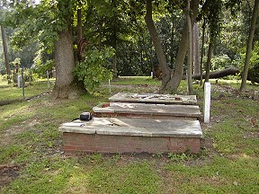 | 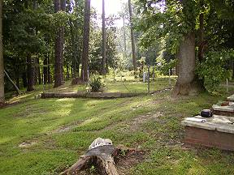
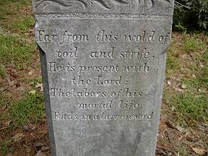 | 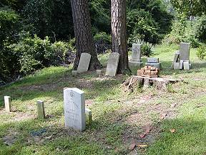
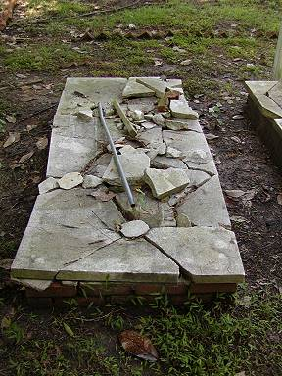 | 