First Gravel Hill_Old Stage Rd_Original Cemetery (behind manse)
Transcribed by members of the
Grave Site Survey Task Force (GSSTF)
Under the Auspices of
Isle of Wight County Historical Society (IWCHS)
Visited May 18, 2005

A selection of shaving foam, water, or talcum powder was used to improve the legibility of the inscriptions on the older tombstones. Afterwards, a clean water spray was used to remove any residue. GSSTF members were careful not to damage tombstones or artifacts during the transcription process.

Any text within the “[ ]” is a comment about the tombstone inscription, ex., [fs] indicates a footstone inscription. Throughout the transcribing process, an attempt was made to preserve the, ‘look and feel’ of the original inscriptions as regards word spacing, arrangement, and possible misspellings.

Please address your comments/corrections to: albert.b@charter.net or epowellsr@aol.com.

 | Inscription |  |  | Inscription
 | ROBERT L. OSBY  Aug, 21, 1916  Nov, 10, 1978 |  |  | CARRIE C. OSBY  Oct, 15, 1885
 | NANCY g BAKER  Mar 11 1952  Mar 12 1952 |  |  | DARNELL THOMPSON  Jan 10 1954  Jan 20 1954
 | KATHERIN  THOMPSON  Oct 21 1941  Oct 24 1941 |  |  | VIRGINIA LAURNELL  ROBINSON  Nov. 19, 1921  April 16, 1941
 | ELEANOR THOMPSON  Nov 7 1934  Jan 9 1965 |  |  | “Our BelovedBrother”  JESSIE THOMPSON  Mar. 3, 1927  Nov. 3, 1997q
 | Mr. JOHN WILSON  Died 1948 |  |  | Mother  LUCY ANN  WILSON  Mar. 15, 1860  Jan. 16, 1942  At Rest
 | Mrs. MARY KING  Died 1934 |  |  | Wife  MARIE BURNETT  Feb. 17, 1902  Mar. 21, 1948
 | In Loving Memory of  CORTLAND WILLIAMS  1923 (golf bag) 1999 |  |  | MARY J. JONES  Sept, 23, 1947
 | WALTER JONES  March 21, 1942 |  |  | ALLEN  WELLS  Virginia  PVT  US Army  World War I  November 25, 1895  November 28,1957
 | JAMES A, JONES  Jan, 12, 1936 |  | [hs]  [slab] | ALTON FENWICK BOWENS  Virginia  PFC US Army  Aug 9 1936 [sic] Oct 20 1960  ALTON F, BOWENS  Born Aug, 9, 1938 (sic)  Died Oct, 20, 1960
 | ANNA P. WELLS  Feb, 22, 1892  Sept, 18, 1978 |  |  | CHRISTINE W. WALKER  Jan 13 1931  Aug 21 1987
[hs]  [slab] | MATTHEW K BOWENS  PVT US Army  Korea  1929 1962  MATTHEW K. BOWENS  Feb 16 1929  Aug 4 1962 |  |  | ALBERTA BOWEN  Died 1938
 | Beloved Mother  LIZZIE BROWN  Feb. 21, 1883  May 14, 1943 |  |  | ARTHUR W. OWENS SR,  Jan, 12, 1913  March 13, 1991
 | LOTTIE P. OWENS  Oct,9, 1922  Oct, 15, 1993 |  |  | LUTHER TYNES  Aug 8 1904  Apr 21 1974
 | JOHN W. TYNES  July 3, 1902  April 25, 1968 |  | [hs]  [slab] | Mother Father  PRISCILLA K. ALGIE, SR,  March 10,1898 Aug, 15[sic] 1895  June 25, 1984 Sept, 11, 1979  BOWEN  PRISCILLA ALGIE BOWENS SR.  Mar 10, 1898 Aug, 14[sic], 1895  June 25, 1984 nov, 11, 1979
 | MAGGIE J  BAILEY  Apr 30 1905  Sept 23 1994  Poole |  |  | LUTHER TYNES JR  Sept 12 1944  Oct 25 2002  Prelow Chapman
 | LUCY JANE TYNES  Dec. 4, 1945  Oct. 11, 1949 |  |  | JOHN H CLAGGETT  May 24, 1913  March 19, 1996
 | ALBERTA H. CLAGGETT  Sept 15, 1913  Jan 26, 1993 |  |  | CHARLIE WYATT HILL  June 21, 1907  Dec 18, 1982  Your Memory is Dear To Us
 | SARAH B. WELLS  Nov. 25, 1907  June 2, 1985  Mother |  |  | P. D. WELLS SR  Feb. 14, 1905  Jan 17,1963  Father
 | ELSIE M. THOMPSON  Aug. 16, 1887  Feb. 13, 1969 |  |  | CHARLES A. THOMPSON  Born Dec. 26 1886  Died April 25 1960
 | WILLIAM H. REID  Born Dec. 25 1878  Died Aug 25 1956 |  |  | THOMAS BOWSER  Jan 3, 1926  Jan 18, 1981
 | MARY TINA BOWSER  June 13, 1897  Oct. 23, 1978 |  |  | JOHNNIE BOWSER  Born Dec 26 1887  Died Feb 10, 1961
 | ALICE W. WILLIAMS  Born Jan, 10 1855  Died Oct, 14 1924 |  |  | Mother  ELLA LOUISE HILL  July 18, 1880  Dec. 29, 1949
 | Beloved Brother  JUNIUS G. HILL  Oct. 28, 1917  Dec. 17, 1941 |  |  | Beloved Father  BAXTER A. HILL  Jan. 12, 1875  Apr, 28, 1929
 | ALLEN HARRIS  Born Oct 15, 1889  Died Jan 14, 1955 |  |  | In Memory of  JOE JAMES WELLS  Aug, 20, 1898  Apr, 14, 1944
 | JIM W. JOSEPHINE  May 13, 1871 Dec. 25, 1972  Mar. 17, 1943 June 28, 1930  WELLS  Beloved Grandfather Grandmother  J.W. [fs] |  |  | MAJOR B. PIERCE  Born May 18, 1900  Died Nov 12, 1959
 | GEORGE N. BOWSER  March 6, 1937  Aug, 6, 1988 |  |  | JOE BOWSER  Virginia  PVT 543 Engr Service  February 24 1936
 | GEORGIA WELLS GREENE  Nov, 27, 1908  May 15, 1948 |  |  | VIVIAN GREENE  April 4, 1931  May 15, 1948
 | EARL JONES BYRD  Born Jan, 31, 1933  Died Feb, 18, 1962 |  |  | [unmarked grave]
 | JOHN WALTER BANKS  Virginia  COX USNR  World War II  Oct 9 1923 Apr 10 1953 |  |  | SHERMAN BERNARD REESE  Virginia  Stn 2 USNR  World War II  Oct 9 1925 March 8 1964
 | MARIE P REESE  Jan 9, 1901  April 24, 1966 |  |  | VIRGINIA A. REESE  Aug 26 1920  July 4 1968  At Rest
 | GLORIA W. REESE  Sept. 16, 1921  Dec, 18, 1959  Loved By All |  |  | THOMAS T WELLS  Virginia  SP4 US Army  Vietnam  April 13 1945 Aug 24 1970
 | MARY B. WELLS  March 31, 1881  March 13, 1968 |  |  | MARGARET JOHNSON  October 5 (no birth year)  October 10 1952
 | ROBERT L. RUTH J.  May 5, 1901 Feb. 10, 1906  Sept 2, 1986 July 2, 1979  HILL |  |  | CLAR MILLER  Died Jan. 30, 1964
 | H. F. MILLER COBIN  Born Aug. 25, 1912  Died March 20, 1931  Gone but not forgotten |  |  | ELIZA HOLLOMAN  Sept 10, 1902  Sept 12, 1981
 | LAURA H. CLAGGETT  Feb. 17, 1884  Jan 2, 1979 |  |  | ROBERT CLAGGETT  Born March 26, 1866  Died Jan. 12, 1965
 | VINCENT A. KING  March 31, 1938  March 19, 1972 |  |  | MARY L. KING  Aug. 24, 1928  Feb. 20, 1994
 | GEORGE SMITH  1878 – 1940 |  |  | MARY SMITH  1880 – 1969
 | JESSE TYNES  Born April 30, 1896  Died Jan. 9, 1960  At Rest |  |  | WILLIE JEFFERSON  Sept, 26, 1902  April 2, 1960
 | PRISCILLA  JEFFERSON  Sept 22 1906  Feb 15 1995  Poole |  |  | GRACE H  BRADBY  Mar 28 1910  Apr 12 1993  Poole
 | HUBERT BRADBY SR.  Born Oct 28 1903  Died July 13 1958 |  |  | TRACY ANN BRADBY  Feb. 14, 1964 – Feb. 18, 1964  Infant Daughter of Allen & Natalie
 | REV BOLDEN BRADBY  Born Sept 27 1897  Died Oct 11 1958 |  |  | EDDIE R. BRADBY  1901 – 1992  Tucker Service
 | MILES BRADBY  Dec, 12, 1895  Feb, 2, 1978  Bradby Service |  |  | HILTON AVERY  JOSEPH  1877 – 1933
 | [unmarked slab] |  |  | [unmarked slab]
[hs] | [no inscription, or erased slab] |  | [slab] | MILTON L, BRADBY  Aug,18, 1898  Sept. 11, 1968
 | JULIA HILL BRADBY  Born Sept, 12, 1903  Died Jan, 17, 1960 |  |  | HENRY HARRIS  Jan 1, 1926 – Jan 1, 1999  Pooles Funeral Home
 | SAMUEL HARRIS  Born Aug 3, 1890  Died July 8, 1958 |  |  | SUSIE B HARRIS  Dec 12 1898  June 10 1984
 | JOSEPH CLAYTON  Jun 24, 1978 |  | [see 1st photo below] | ELK  No. 97S  210. C[?]  Pbe 221
 | DANIEL W. HARRIS SR.  Mar. 12, 1933  Jan 25, 1992  Poole |  | [hs]  [bronze]  [slab] | ARTHUR M HARRIS  PVT US Army  World War II  1923 1982  ARTHUR M. HARRIS  May 25 1923  Dec 20 1982
 | [unmarked grave] |  |  | PATDILLA  [illegible] 17, 1925  Dec 6 1927
 | JAMES KING  June – 25 – 1902  July – 12 – 1961  Pooles Service |  |  | CLARA B  KING  Sept 1 1904  Nov 27 1993  Poole F H
 | [metal sign … no markings] |  |  | MARY L SPARKS  1890 – 1956
 | [unmarked grave]

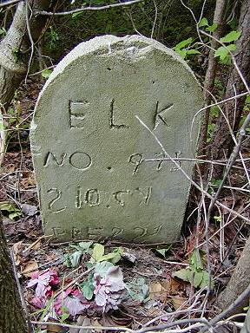 | 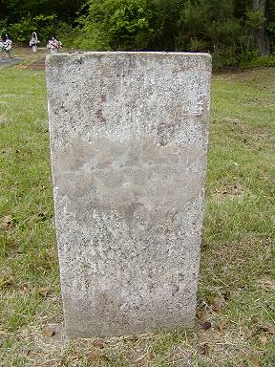
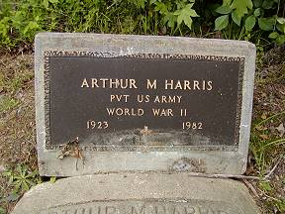 | 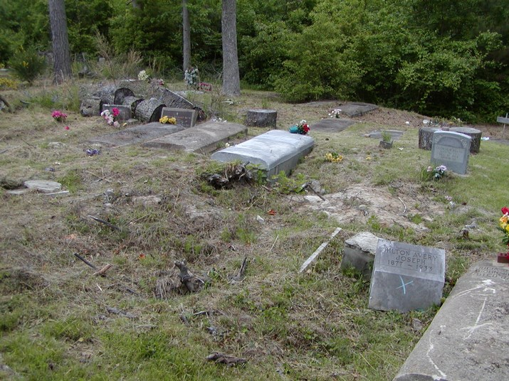
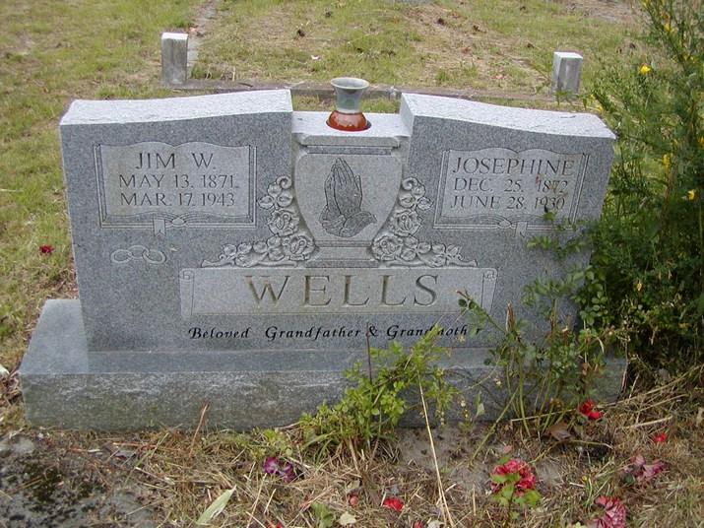 | 