Gardner ~Glen Haven Rd~ Cemetery
Transcribed by members of the
Grave Site Survey Task Force (GSSTF)
Under the Auspices of
Isle of Wight County Historical Society (IWCHS)
Visited April 2, 2009

GSSTF members were careful not to damage tombstones or artifacts during the transcription process. Any text within the “[ ]” is a comment about the tombstone inscription, ex., [fs] indicates a footstone inscription. Throughout the transcribing process, an attempt was made to preserve the, ‘look and feel’ of the original inscriptions as regards word spacing, arrangement, and possible misspellings.

Please address your comments/corrections to: albert.b@charter.net or epowellsr@aol.com.

 | Inscription |  |  | Inscription
JOHN FRANK GARDNER
Nov 12, 1933
July 26, 1934
Notes: One would assume that, with a cemetery of this size, more than one person would be interred here; however, no other markers were visible.
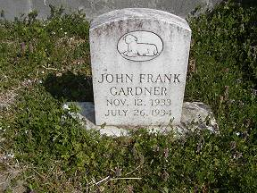 | 