Gray ~ Bob White Rd ~ Cemetery
Transcribed by members of the
Grave Site Survey Task Force (GSSTF)
Under the Auspices of
Isle of Wight County Historical Society (IWCHS)
Visited

A selection of shaving foam, water, or talcum powder was used to improve the legibility of the inscriptions on the older tombstones. Afterwards, a clean water spray was used to remove any residue. GSSTF members were careful not to damage tombstones or artifacts during the transcription process.

Any text within the “[ ]” is a comment about the tombstone inscription, ex., [fs] indicates a footstone inscription. Throughout the transcribing process, an attempt was made to preserve the, ‘look and feel’ of the original inscriptions as regards word spacing, arrangement, and possible misspellings.

Please address your comments/corrections to: albert.b@charter.net or epowellsr@aol.com.

 | Inscription |  |  | Inscription
 | Grandfather  WILLIAM NELSON  GRAY  Born Jan. 14, 1824  Died Sept. 17, 1915  I have fought a good fight,  I have finished my course,  I have kept the faith. |  |  | Grandmother  MATILDA S. HALL  His Wife  Born June 7, 1826  Died Feb. 19, 1916  They loved her most,  Who knew her best.

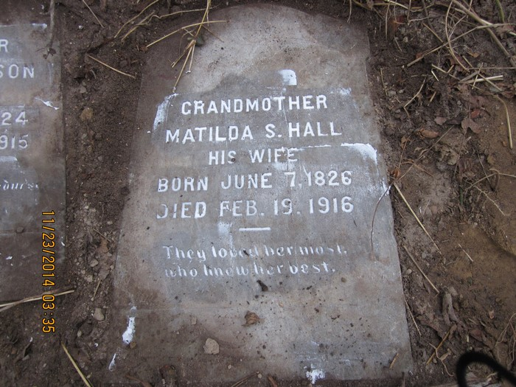 | 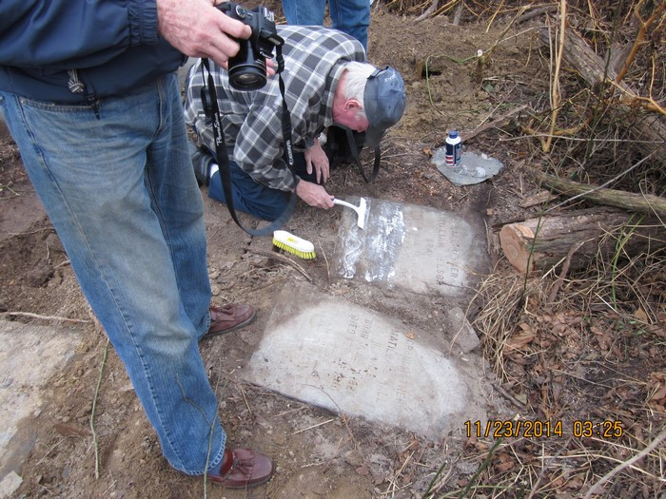
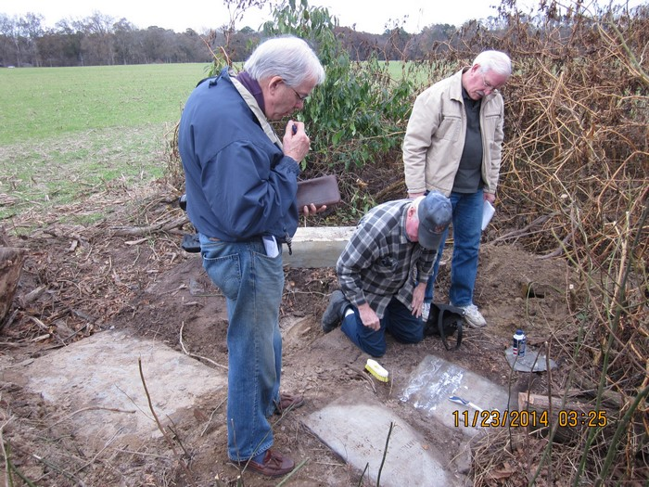 | 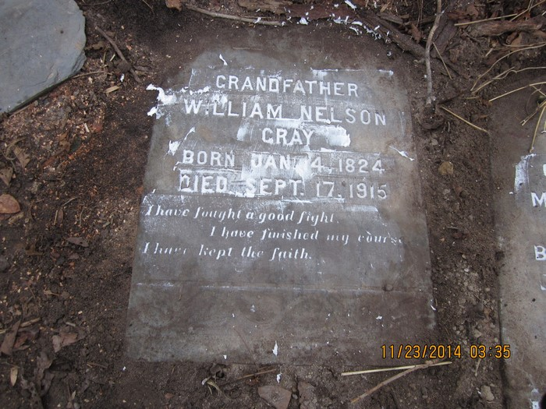
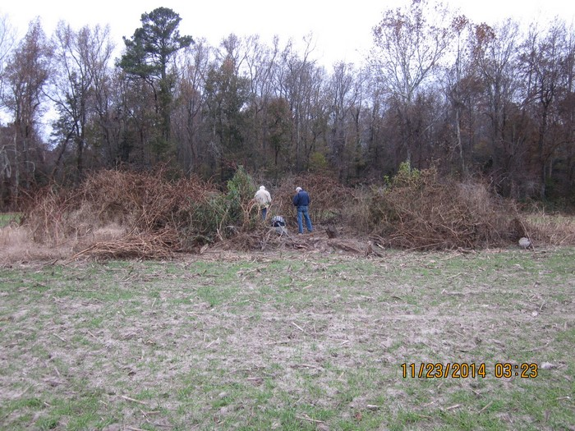 | 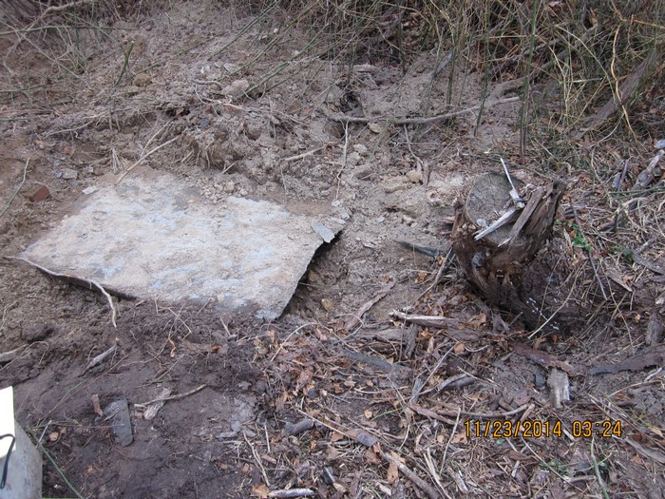
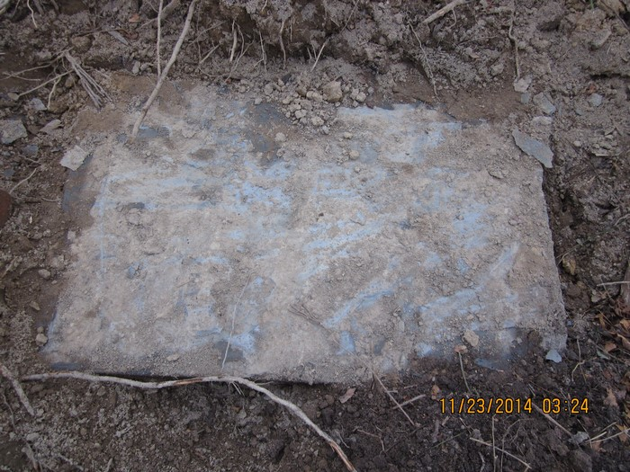 | 