GWALTNEY ~Dews Plantation Rd~ Cemetery
Visited by Members of
Grave Site Survey Task Force (GSSTF)
Under the Auspices of
Isle of Wight County Historical Society (IWCHS)
May 16, 2004

This burial site lies in the woods across Dews Plantation Road from the Ferguson home, located about 0.6 miles north of Raynor Rd. The Gwaltney family formerly owned the adjacent land. The area surrounding the single tombstone is heavily overgrown with poison ivy in abundance.

Throughout the transcribing process, an attempt was made to preserve the, ‘look and feel’ of the original inscriptions as regards word spacing, arrangement, and possible misspellings.

Please address your comments/corrections to: albert.b@charter.net or epowellsr@aol.com.

Mrs. VIRGINIA GWALTNEY
Born
June 18, 1824
Died
April 12, 1896
________________

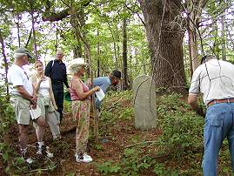 | 