Hall ~Halltown Rd~ Cemetery
Transcribed by members of the
Grave Site Survey Task Force (GSSTF)
Under the Auspices of
Isle of Wight County Historical Society (IWCHS)
Visited May 3, 2015

This small cemetery is located in a wooded section of a farm field about 1/8 mi from Halltown Rd and Raynor Rd intersection. A selection of shaving foam, water, or talcum powder was used to improve the legibility of the inscriptions on the older tombstones. Afterwards, a clean water spray was used to remove any residue. GSSTF members were careful not to damage tombstones or artifacts during the transcription process.

Any text within the “[ ]” is a comment about the tombstone inscription, ex., [fs] indicates a footstone inscription. Throughout the transcribing process, an attempt was made to preserve the, ‘look and feel’ of the original inscriptions as regards word spacing, arrangement, and possible misspellings.

Please address your comments/corrections to: albert.b@charter.net or epowellsr@aol.com.

 | Inscription |  |  | Inscription
 | ROBERT HENRY HALL  Dec. 25. 1864 – May 14. 1933  ----------------  He was a Christian and faithful  Church member sixty years.  ----------  A Little while and all his saints  Shall dwell in hallowed unison  Indivisable ------ Goodnight  R. H. H. [fs] |  |  | CARRIE HALL  Died Dec 9. 1942
 | [tombstone, but no inscription] |  |  | [unmarked grave]
 | [unmarked grave] |  |  | [unmarked grave]
 | [unmarked grave]

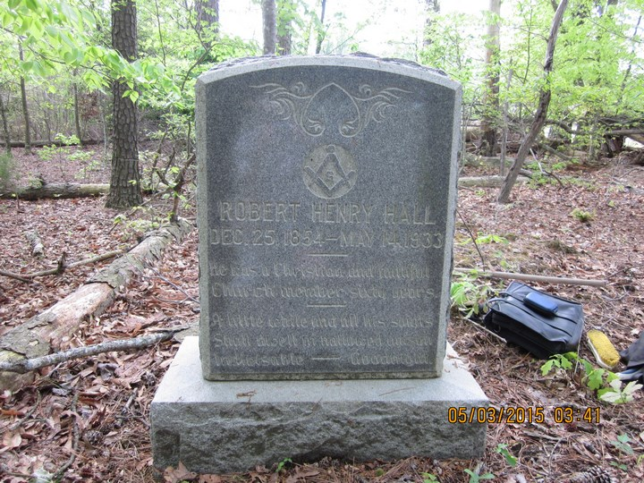 | 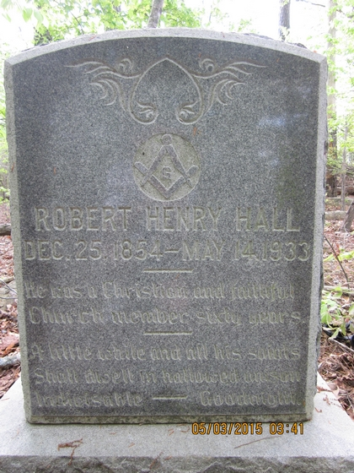
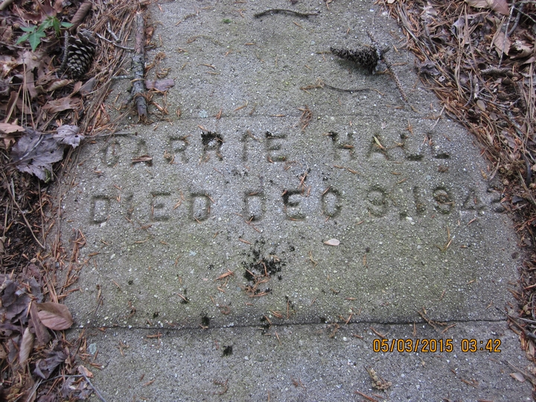 | 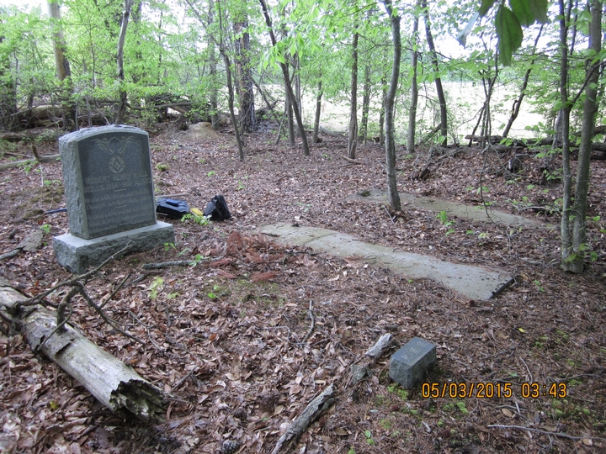
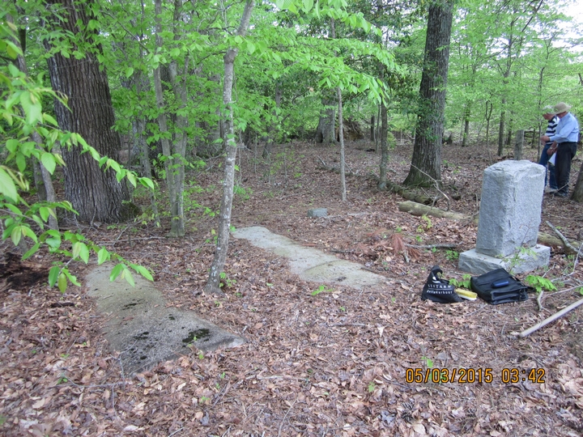 | 