Herring ~Titus Creek Dr~ Cemetery
Transcribed by members of the
Grave Site Survey Task Force (GSSTF)
Under the Auspices of
Isle of Wight County Historical Society (IWCHS)
Visited September 4, 2013

Location: Behind private residence on Titus Creek Dr

A selection of shaving foam, water, or talcum powder was used to improve the legibility of the inscriptions on the older tombstones. Afterwards, a clean water spray was used to remove any residue. GSSTF members were careful not to damage tombstones or artifacts during the transcription process.

Any text within the “[ ]” is a comment about the tombstone inscription, ex., [fs] indicates a footstone inscription. Throughout the transcribing process, an attempt was made to preserve the, ‘look and feel’ of the original inscriptions as regards word spacing, arrangement, and possible misspellings.

Please address your comments/corrections to: albert.b@charter.net or epowellsr@aol.com.

 | Inscription |  |  | Inscription
WILLIES B.
HERRING
~
New York
~
Pvt. 152 Depot Brig
April 29, 1940

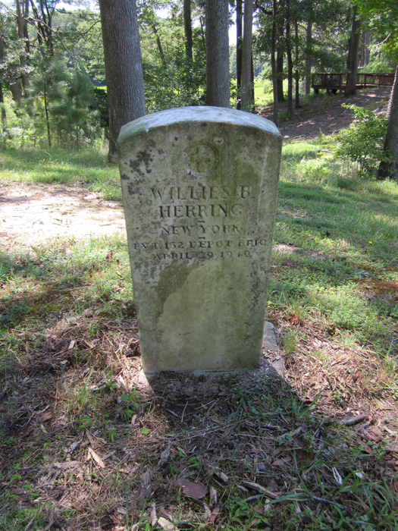 | 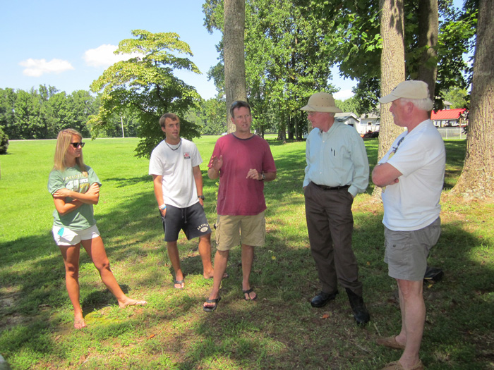

Willies Booker Herring was born on 14 September 1891 at Battery Park, VA according to records.

His father, John Herring was born in about 1860 in North Carolina. I have not been able to find a death date on him yet, or when he moved to Virginia, but he married Willies' mother Elizabeth Drew in Isle of Wight County on 27 November 1890. The 1910 U.S. shows John and his family living in the Newport District of Isle of Wight County. He is listed as a farm laborer and a wage earner and that he was renting the house he lived in. He may have been a sharecropper, but it was unlikely he owned the property on which he was farming. John was listed as being unable to read or write. I cannot find the record, but he died before 1920 because the 1920 U.S. Census lists his wife as a widow and the head of the household. In fact John died before June 1917 because on Willies' draft registration card that was completed on June 5, 1917, he states that he has a mother, two sisters, and one brother dependent on him. Willies claimed an exemption from the draft because of this dependency, but he served anyway.

Willies' mother, Elizabeth Drew Herring was born on 09 October 1875 in Isle of Wight County to Booker Drew and Louisia Tynes Drew. Elizabeth is listed on the 1910 U.S. Census as being able to read and write. Elizabeth Drew married John Herring on 27 November 1890. She had turned 15 the month before. Between 1889 (when she was still 14) and 1912, Elizabeth had 13 children. Five of the children died at the age of two or younger, including her first born, Eliezeoner, (1889-1891). Willies Booker Herring was the second born, 14 Sept 1891. Although he grew up in Isle of Wight County, at some point in early 1917 or prior to that, Willes moved to Brooklyn, NY to work at the Brooklyn Navy Yard. In 1917, Willies was living at 1310 Avenue X in Brooklyn, which is in the Sheepshead Bay section of town.

Willies was inducted into the Army on August 2, 1918. He was initially assigned to the 152nd Depot Brigade at Camp Upton, which was in Suffolk County on Long Island. Camp Upton was a port of embarkation for the U.S. Army during WW I. Depot brigades , were used during WW I to receive and organize recruits, provide them with uniforms, equipment and initial military training, and then send them to France. Willies was with 24th Company (Colored). The 152nd Dept Brigade may have simply been basic training for Willies because on Sept 12, 1918 he was transferred to Company D of an Automatic Replacement Draft, Colored Replacement Battalion and sent to France. He served in France from Sept 20, 1918 to July 18, 1919. I cannot find Willies' service record in France, but one source states that he served with Depot Service Company #24, Army Service Corps. Willies received an honorable discharge on July 25, 1919 as part of the general demobilization of forces.

After the war, Willies began working at the Brooklyn Navy Yard again. He married Berdelia Dugger on June 12, 1936. Berdelia had one child, William Kaiser Dugger, born July 22, 1918. In the 1940 US Census,William is living with Willies and Berdelia at 253 Greene Avenue in Brooklyn. William is listed as William Herring, but this is an error because William's later documents show his last name as Dugger. William may not have known his birth father because his mother's maiden name was Dugger and Willies could have been William's step father.

Willies died of Pulmonary Tuberculosis on April 29, 1940 at the Kings County Hospital in Brooklyn. Berdelia served as the informant for the death certificate. Willie's body was shipped to Virginia and he was buried in an unmarked grave in the Herring Family cemetery. His mother Elizabeth made an application for a veteran's headstone in June 1941. The government ordered it in July 1941 and it was shipped in Sept 1941. That's the headstone on our property.

Willies' surviving brothers and sisters appeared to stay in or near Isle of Wight as did many of their children and grandchildren.

