Hickory Neck ~Joyners Bridge Rd~ Cemetery
Transcribed by members of the
Grave Site Survey Task Force (GSSTF)
Under the Auspices of
Isle of Wight County Historical Society (IWCHS)
Visited September 21, 2005

A selection of shaving foam, water, or talcum powder was used to improve the legibility of the inscriptions on the older tombstones. Afterwards, a clean water spray was used to remove any residue. GSSTF members were careful not to damage tombstones or artifacts during the transcription process.

Any text within the “[ ]” is a comment about the tombstone inscription, ex., [fs] indicates a footstone inscription. Throughout the transcribing process, an attempt was made to preserve the, ‘look and feel’ of the original inscriptions as regards word spacing, arrangement, and possible misspellings.

Please address your comments/corrections to: albert.b@charter.net or epowellsr@aol.com.

 | Inscription |  |  | Inscription
 | HENRY JAMES PHIPPIN  Born 1928  Died 1927  Baby Boy |  |  | OTHIA FOSTER  Born – Dec. 29, 1944  Died – Jan. 1, 1945
 | GEORGE H. FOSTER  Born July 19[unreadable]  Died [unreadable] |  |  | [concrete ledger stone – unreadable]
 | MILL W DARDEN  1878 – 1955  I.O. Hill & Company |  |  | ELIZABETH DARDEN  1883 – 1953  I.O. Hill & Company
Note (1) | [unmarked grave] |  | Note (1) | [unmarked grave]
Note (1) | [unmarked grave] |  | Note (1) | [unmarked grave]
Note (1) | [unmarked grave]
Note (2) | [unmarked grave] |  | Note (2) | [unmarked grave]

Notes:
- These unmarked graves are near the rear of the cemetery
- These unmarked graves are near the front of the cemetery

In an interview with a Mr. James “Wesley” Holland, he remembers that the following persons are buried in this cemetery … GSSTF members were unable to verify his information. It is provided for historical purposes.

WOODVILLE DARDEN
MARGARET WATKINS DARDEN
WILLIAM “BILLY” DARDEN (possibly buried here)
BETSY CARR DARDEN
PATTY DARDEN
GEORGE HEDGEPETH (see below)
NANNIE HEDGEPETH (see below)

On your report you have:

In an interview with a Mr. James “Wesley” Holland, he remembers that the following persons are buried in this cemetery … GSSTF members were unable to verify his information. It is provided for historical purposes.

WOODVILLE DARDEN
MARGARET WATKINS DARDEN
WILLIAM “BILLY” DARDEN (possibly buried here) [Mills W Darden]
BETSY CARR DARDEN [Elizabeth Darden]
PATTY DARDEN
GEORGE HEDGEPETH see below
NANNIE HEDGEPETH see below

Marker for: Henry James Phippin
great grandson of J W Darden
Va Dept of Vital Records 26931
Henry James Phippin - W M single
dob: 28 Jan 1928 in Isle of Wight
dod: 12 Nov 1929 in Isle of Wight of ____ _____ menigitis
father: Lee Phippin born in MD
mother: Nannie Hedgepeth born in Isle of Wight
burial: W Darden Cemetery 24 Nov 1929 by C W Bailey
informant: Lee Phippen Jr

Othia Foster - great granddaughter of J W Darden
Dau of Dollie Hedgepeth & George Hester Foster

James Woodville Darden (born abt 1847 – died bet 1920-1927, son of John & Margaret) married Margaret Watkins (born abt 1844 – died aft 1920) abt 1871

The Smithfield Times, Thurs 31 Mar 1955 p 1 col 2
Mills Wm Darden
Died March 24th
Mills William (Billy) Darden, 76, retired farmer of Isle of Wight County, died March 24, 1955, at his home near Windsor after a long illness. He was the husband of the late Elizabeth Carr Darden and the son of James Woodville Darden of Isle of Wight County. He is survived by a daughter Mrs E I Benton of Isle of Wight County; four sons, J W & W L Darden of Carrsville, M W Darden Jr & J H Darden of Windsor; a sister Mrs Laura Hedgepeth of Windsor; 11 grandchildren and four great grandchildren.
[Mrs E(lisha) I(saac) Benton was Sadie Darden, JW – John W Darden, W L - Whittie Lee Darden, MW – Mills William Darden Jr, J H – Joseph H; sister Mrs Laura Darden Hedgepeth wife of James A Hedgepeth brother to the George Hedgepeth.]
George Hedgepeth (born abt 1869 – 28 Mar 1937, son of Isaac & Edith Hedgepeth) [George Allen Hedgepeth]
The Smithfield Times Thursday 1 Apr 1937
Deaths
George A Hedgepeth
George A Hedgepeth, aged 68, died March 28th at 10:30 o’clock at the family residence near Zuni; He is survived by four daughters, Mrs R S Turner of Windsor, Mrs Lee Thippin of Zuni; Mrs Hestor Forter of Portsmouth; and six sons, L L, William, George, Donald, Darden and Burton Hedgepeth all of Windsor.
Funeral services were conducted Sunday afternoon at 2 o'clock at the residence by the Rev W R Buhler and the Rev J Sidney Cobb. Burial was in the cemetery on the Woodville Darden farm near Windsor.
Nannie Hedgepeth (1 Apr 1874 – 4 Apr 1929)
Va Dept Vital Records Cert No: 11050 Isle of Wight Co, Va
Nancy Otelia Hedgepeth - F – W
spouse: George Hedgepeth
dod: 4 Apr 1929 of labor pneumonia
dob: 1 Apr 1874 in IOW
father: Woodwill Darden
mother: Marguerite Watkins
informant: G A Hedgepeth of Windsor
burial: 6 Apr 1929 in Woodwill Darden farm

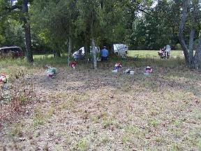 | 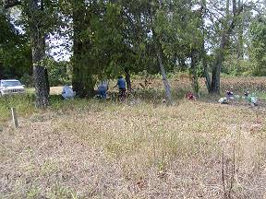
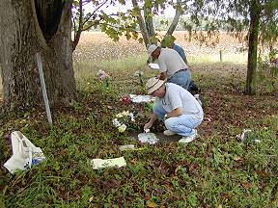 | 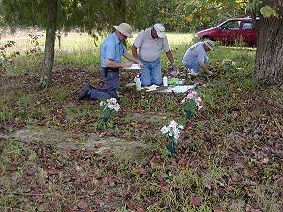
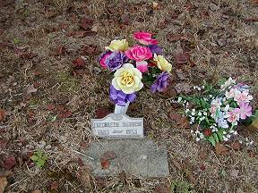 | 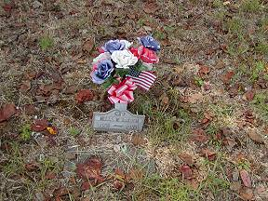
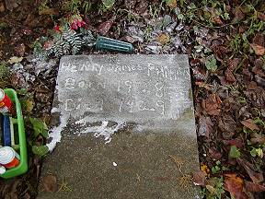 | 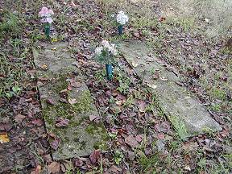
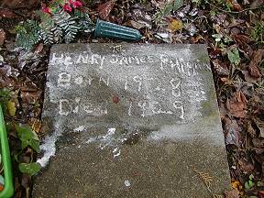 | 