HOLLADAY ~Breezewood Dr~ Cemetery

Visited by Members & Volunteers of
Isle Of Wight Historical Society
January 4, 2004

The official name (if there is one) of this cemetery is unknown; however, the common practice of naming a cemetery by the predominance of its inhabitants has been adopted for the purpose of this report. The cemetery is located on Breezewood Tr (off of Sugar Hill Road in Carrollton) and is heavily overgrown with briars, bushes, weeds, and debris from hurricane Isabel. Remnants of a wire fence were found although it was not possible to ascertain whether it marked the boundaries of the cemetery or was intended for some other purpose.

Team members were careful not to disturb artifacts or damage tombstones … a mixture of shaving foam and water was used with a soft brush to clean and make legible the inscriptions on the tombstones. Afterwards, a water spray was used to remove any residue from the stones.

Any text in the table that is surrounded by the, “[“ and “]” are explanatory comments and are not inscribed on the stone … [fs] indicates a footstone and [hs] indicates a headstone.

Please address your comments/corrections to: albert.b@charter.net or epowellsr@aol.com.

Photo ID # | Inscription |  |  | Photo ID # | Inscription
1 | MARGARET W. LARKINS  Born  June 28, 1841  Died  May 9, 1880  “Rest, Mother, Rest in quiet sleep,  While children in sorrow o’er weep  Where the weary are at rest she is  gathered unto God, lo! the pain of life  is past. All her warfare now is over.”  M.W.L. [fs] |  |  | 2 | JULIA BETTS  Died  Oct. 26, 1902  Age 83 years  “Rest in Peace”  J.B. [fs]
3 | JOHN D. BETTS  Born  Nov. 26, 1832  Died  Jan. 3, 1896  “Forever with the Lord  At rest in Heaven” |  |  | 4  Notes (1) (3) | THOMAS H. CORBELL  Young’s Co.  VA C.A.V.  C.S.A.
5 | EMILY J.  Daughter of  THOS. H. & NANNIE J. CORBELL  Born Sept. 30, 1822  Died Apr. 14, 1884  “Farewell Daughter, Oh farewell,  you have gone to heaven to dwell.  Soon I will meet you on that shore  when we will meet to part no more.” |  |  | 6 | CALVIN D. HOLLADAY, JR.  Born  April 9, 1872  Died  December 12, 1944  Junior [fs]
7 | HOLLADAY |  |  | Note (2) | 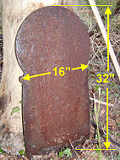
7 | MARTHA F. HOLLADAY  Born  Oct. 4, 1851  Died  June 8, 1928  Mother [fs] | CALVIN D. HOLLADAY  Born  Dec. 23, 1847  Died  July 6, 1898  Father [fs] |  | Note (2)
7 | “Dear parents, tho’ we miss you much,  We know you rest with God.” |  |  | Note (2)

NOTES:
- Has spike in ground at the footstone location, 6’ 2” from headstone.
- Heavy metal marker of some type but no inscription was visible … broken at the bottom which could indicate that it was mounted somewhere in the cemetery but the base attachment was not found.
- C.S.A. is “Confederate States of America” --- VA C.A.V. indicates a Virginia cavalry division.

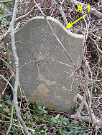 | 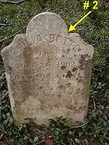
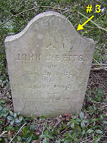 | 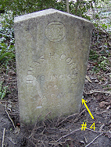
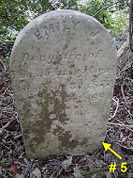 | 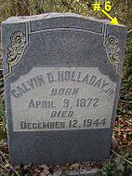
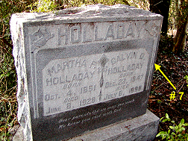 | 