Holland ~Bobcat Ln~ Cemetery
Transcribed by members of the
Grave Site Survey Task Force (GSSTF)
Under the Auspices of
Isle of Wight County Historical Society (IWCHS)
Visited February 8, 2006

GSSTF members wish to thank Pat Holland for her able assistance in locating this cemetery … she has been a tremendous help in locating other cemeteries in the Carrsville area.

A selection of shaving foam, water, or talcum powder was used to improve the legibility of the inscriptions on the older tombstones. Afterwards, a clean water spray was used to remove any residue. GSSTF members were careful not to damage tombstones or artifacts during the transcription process.

Any text within the “[ ]” is a comment about the tombstone inscription, ex., [fs] indicates a footstone inscription. Throughout the transcribing process, an attempt was made to preserve the, ‘look and feel’ of the original inscriptions as regards word spacing, arrangement, and possible misspellings.

Please address your comments/corrections to: albert.b@charter.net or epowellsr@aol.com.

 | Inscription |  |  | Inscription
 | In Memory of  WALTER B. HOLLAND  Born Aug. 25, 1843  Died Apr. 15, 1878 |  |  | RETTA HOLLAND  Born  March 22, 1825  Died  February 15, 1880  R.H. [fs]
 | [no headstone located]  E.L.H. [fs] |  |  | My Beloved EMMA  EMMA L.  wife of  ROB’T. A. EDWARDS  Daughter of  JOHN M. & HENRIETTA HOLLAND  Born Jan. 15, 1859  Died Dec. 12, 1886  Gently the passing spirit fled  Sustained by Grace Divine  Oh! May such grace on me be shed  And make my end like thine
 | Our Beloved Tobie  In Memory of  A. J. HOLLAND  Born Feb. 25, 1851  Died Oct. 27, 1871  J.D. Cowper  Norfolk |  |  | [no headstone visible]  S.E.H. [fs]
 | [no headstone visible]  H.H. [fs] |  |  | [no headstone visible]  J.H.H. [fs]
 | In Memory of  Little  TAZEWELL T. HOLLAND  Born June 7, 1835  Died Sept. 5, 1836  T.T.H. [fs] |  | Note (1) | In Memory of  SUE E. HOLLAND  Born Sept. 7, 1848  Died Jany, 28, 1871  S.E.H. [fs]
 | In Memory of  J. HENNING HOLLAND  Born  Oct. 7, 1841  Died  Dec. 18, 1867 |  |  | [no visible headstone]  L.H.M. [fs]
 | In Memory  JOHN M. HOLLAND  Born Nov 19, 1809  Died Feb. 10, 1871  ----------  J.M.H. [fs] |  |  | [no visible headstone]  A.M.H. [fs]
 | My Dear Sister  MRS HENRIETTA HOLLAND  Born  November 1st 1818  Died  December 13th 1880  --------  Erected by her Brother  JOSEPH LENOW |  |  | Sunshine Weds with Shade  to  The Memory of  ANTOINETTE M. HOLLAND  Born July 21st 1836,  Died Apr. 15th 1854  Aged 17 yrs 8 mo’s  & 24 days.  ---------  Mighty in Faith and Hope, be not thou sad.  Sever the green wishes, look up & be glad.  See all around thee below and above.  The beautiful, the bountiful gifts of God’s Love  What though your Hearts beat with  death’s sullen waves:  What though the green sod is broken by graves:  The sweet hopes that never shall fade  from their bloom,  Make their dim birth chamber down in the tomb.

Notes:
(1) The word, “Jany” is actually engraved on the tombstone, not a typo.
(2) The blue marks on some of the tombstones is due to the use of a soft chalk, commonly called “sidewalk chalk” to increase legibility so the inscriptions could be read. It does not damage the stone and is dissipated by rain or even heavy dew.

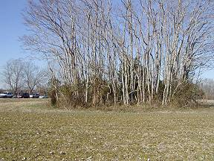 | 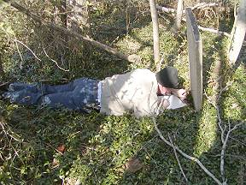
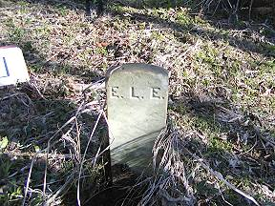 | 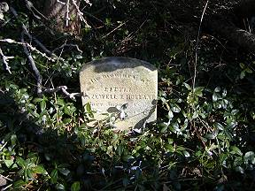
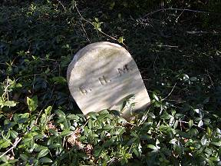 | 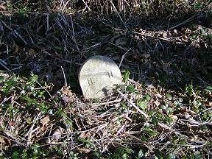
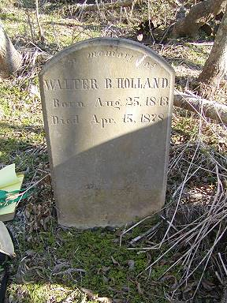 | 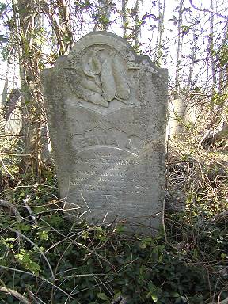
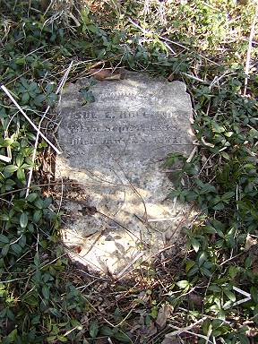 | 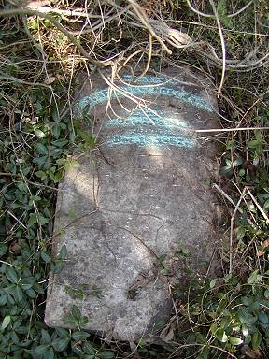
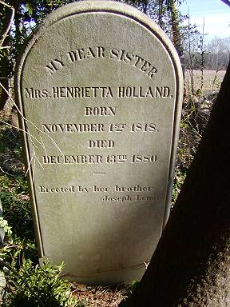 | 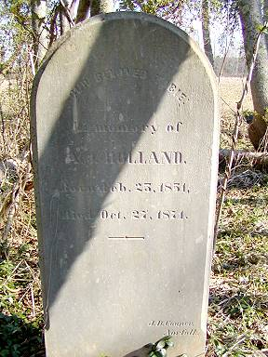
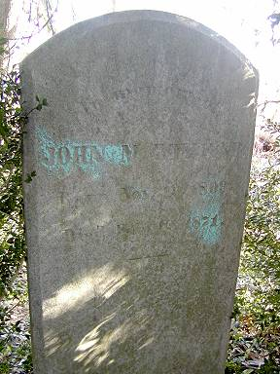 | 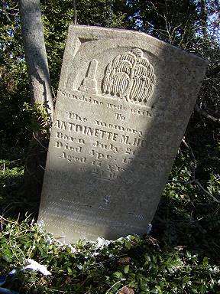
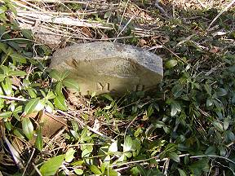 | 