Holly Grove A.M.E. Church ~Orbit Rd~ Cemetery
Transcribed by members of the
Grave Site Survey Task Force (GSSTF)
Under the Auspices of
Isle of Wight County Historical Society (IWCHS)
Visited May 25, 2005

The cemetery is located adjacent to the Church on Orbit Road … most of the tombstones are in good condition and the inscriptions are legible. In a few cases, the crypt stone inscriptions were handwritten and almost illegible; however, most of them were deciphered.

A selection of shaving foam, water, or talcum powder was used to improve the legibility of the inscriptions on the older tombstones. Afterwards, a clean water spray was used to remove any residue. GSSTF members were careful not to damage tombstones or artifacts during the transcription process. A soft chalk (sometimes called ‘sidewalk chalk’) was used to mark the tombstones that were transcribed to prevent duplication and omissions … a light rain or even a heavy due will eradicate the marks after a few days and no damage is done to the tombstones.

Any text within the “[ ]” is a comment about the tombstone inscription, ex., [fs] indicates a footstone inscription. Throughout the transcribing process, an attempt was made to preserve the, ‘look and feel’ of the original inscriptions as regards word spacing, arrangement, and possible misspellings.

Please address your comments/corrections to: albert.b@charter.net or epowellsr@aol.com.

 | Inscription |  |  | Inscription
 | SAMMIE BROWN  Died Nov. 22, 1948 |  |  | HENRY COPELAND  Mar. 10, 1867  Jan. 1, 1951  Loving Husband of CHARLOTTE COPELAND
 | LLOYD D. HAWKS  Sept. 18, 1895  Oct. 29, 1961 |  |  | FLEMUEL D. HAWKS  Feb. 13, 1927  June 2, 1992
 | MOLLIE K. PITTMAN  Jan. 12, 1921  June 28, 1992  “Evangelist”  Wife and Mother |  |  | ROY PITTMAN  July 15, 1918  June 7, 1984  In memory of Husband and Father
 | MILDRED MERRIMAN  June 30, 1930  April 13, 1994 |  |  | JAMES E. WEAVER  Dec. 18, 1918  Nov. 18, 1984
 | WILLIAM S. WEAVER  OCT. 6, 1906  May 28, 1996  A pillar to the Family |  |  | SHERMAN W. WEAVER  Dec. 5, 1876  Dec. 4, 1960  Father [fs]
 | ROBIN WALKER  Aug. 11, 1965  Aug. 12, 1965 |  |  | M  o  t  h  e  r | ELSIE WEAVER GRAY  July 23, 1915  November 28, 1996  We’ll always love you
 | WILLIAM PORTER  JULY 9, 1935  Jan. 18, 1990 |  |  | JAMES R. HATTIE L.  Oct. 17, 1913 Oct. 21, 1915  May 21, 1990 Nov. 11, 1997  PORTER  Our Love goes with you and our souls wait to join you
 | At rest with God  ELIZABETH A. PORTER  Apr. 15, 1943  Feb. 13, 1959 |  |  | WESLEY POPE  Born 1872  died Dec. 1, 1946
 | NECIE PORTER POPE  April 1885  Dec. 21, 1944 |  |  | LINWOOD P. WILSON  April 27, 1900  Nov. 21, 1965
 | ANNA P. WILSON  passed away  Dec. 25, 1942  “Grandma Anna” |  |  | HATTIE ELEY  Dec. 13, 1901  Sept. 6, 1960
 | FRANK G. ELEY  May 24, 1900  May 19, 1985 |  |  | WILLIS ELEY  Nov. 1922  June 1986
 | CHARLES H. WILSON  April 5, 1889  March 9, 1968 |  |  | MARY E. WILSON  Oct. 2, 1899  April 1, 1979
 | JOHN H. WILSON  May 7, 1895  Nov. 1, 1985 |  |  | JESSE J. RICHARDSON  July 15, 1912  Oct. 28, 1984
 | MARY D. RICHARDSON  March 10, 1918  Oct. 27, 2001 |  |  | ALMA WILSON DIGGS  May 19, 1921  Nov. 24, 1986
 | ALICE R. BAILEY  March 20, 1941  March 25, 1992 |  |  | FLORINE W. SMITH  Jan. 21, 1938  March 12, 1993
 | ALICE H. WILSON  Sept. 22, 1926  May 30, 2004 |  |  | DANIEL E. WILSON  May 2, 1921  May 30, 1992
 | JAMES L. WILSON  March 13, 1898  August 30, 1952 |  |  | RUTH WILSON  October 14, 1919  November 2, 1943  Beloved Sister
 | ALICE WILSON  February 22, 1901  October 1968  Beloved Mother |  |  | LENWOOD E. LAWRENCE  CPL US Army  World War II  Sept 20 1914 Dec 15 1955
 | ANNIE LAWRENCE  Aug. 4, 1895  Oct. 2, 1963 |  |  | MALACHI LAWRENCE  Sept. 15, 1887  Dec. 17, 1969
 | HENRY W. LAWRENCE  Pvt US Army  2 Feb 1918 -- 30 Nov 1993 |  |  | In Loving Memory  SCLESTER UZZLE SR  Feb. 2, 1938  June 17, 1999  In loving, Husband, Father, Grandmother and Brother
 | MATTIE J. W. UZZLE  March 20, 1935  March 21, 1998  Beloved Mother, Grandmother, Sister and Aunt |  |  | THOMAS L. UZZLE  CPL US Army  11 Apr 1931 -- 9 Dec 1990
 | JAMES M. WHITE JR  March 29, 1937  July 5, 1983 |  |  | BOBBIE R. ARTIS  Sept. 17, 1956  July 21, 1984
 | CHARLIE BERNARD PITTMAN JR  March 3, 1937  August 28, 1997  The Pillar of our heart |  |  | “Bug”  JOHN JUNIOUS PORTER SR  Feb. 26, 1941  Aug. 27, 2003  In our hearts forever  Brena, Cimp, Johnny & Stacy
 | We will meet again  HARRIETT A. NEWBY  Jan. 28, 1895  Nov. 29, 1974 |  |  | ANNIE M. WHITAKER  Born Dec. 9, 1900  Died July 16, 1974
 | ANNIE CHAPMAN  Born May 15, 1908  died Dec. 28, 1961 |  |  | EMMA H. BUTLER  March 24, 1906  June 21, 1988
 | ANNIE CHAPMAN  Born May 15, 1909  died Dec. 28, 1961 |  |  | EMMA H. BUTLER  March 24, 1906  June 21, 1988
 | WILLIAM B JOHNSON  US Army  Jun 1 1895 Apr 6 1984 [military marker]  WILLIAM B  JOHNSON  June 1 1895  Apr 6 1984 [crypt stone] |  |  | MARTHA W. ANTHONY  Born Sept 23, 1900  Died Nov. 23, 1965
 | JAMES ANTHONY  July 27 1900  July 18 1975 |  |  | JAMES WILLIAMS  Nov 8, 1916  Feb 23, 1990
 | HENRY ARTIS  Jan 19 1908  Oct 4 1989  Pretlow Chapman |  |  | SALLIE MAE ARTIS  April 19, 1916  Mar 17, 2001
 | VIOLET E. RODGERS  Oct. 19, 1932  March 13, 1991 |  |  | ELIE GODFREY  Feb 15, 1908  May 6, 1975
 | GEORGE EVANS  Died May 22, 1962 |  |  | CHARLES C. GLOVER  Died May 16, 1963
 | DONALD E. HERNDON  May 31, 1964  Feb. 23, 1971 |  |  | WILBUR WILSON  Born Oct. 23, 1933  Died Sept. 29, 1957
 | SANDY E. HERNDON  Born Dec. 2, 1925  Died May 23, 1964  SANDY E HERNDON  Virginia  [remainder of stone sunk below ground level] |  |  | JUNIUS W. WALTER  Oct. 17, 1877  June 2, 1964
 | THELMA A. WILSON  Nov. 7, 1907  July 24, 1991 |  | Note (1) | WEAVER  RALPH V. ALICE E.  Mar. 25, 1904 May 12, 1907  Mar. 2, 1968 Mar. 13, 1981  In Loving Memory  RALPH Z WEAVER ALICE E. WEAVER  March 25, 1903 May 12, 1907  March 2, 1968 March 13, 1981
 | MAMIE JOHNSON  Died July 31, 1952 |  |  | Mother  MATTIE B. UZZLE  July 4, 1913  Feb. 13, 1998  The Lord is my shepherd
 | HENRY BUTLER  1893 – 1960 |  |  | GEORGE UZZELL  Mar. 28, 1909  Jan. 31, 1965
 | MARGARET WILLIAMS  Born April 10, 1915  Died May 7, 1961 |  |  | [unmarked grave]
 | LOUISE ELEY  Apr 6 1916  June [illegible] 1985 |  |  | PERNELL WINSLOW  Aug. 15 1947  June 11 1988  Pretlow – Chapman
 | CHARLES H. UZZLE  Oct. 31 1941  Sept. 13, 1996 |  |  | NORA U. MACK  Dec. 4, 1932  Dec. 19, 2000  The Lord is my shepherd
JAMES J. UZZLE, SR.
March 5, 1935
April 26, 2002
Beloved Father

Notes:
(1) The incongruity between, “1903” and, “1904” as the born date for RALPH WEAVER and the middle initial, “Z” and, “V” are not misprints … they are actually engraved on the tombstones.

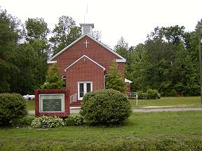 | 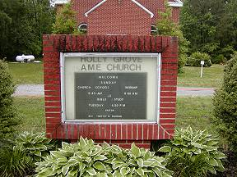
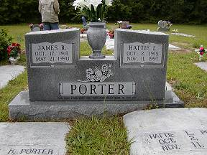 | 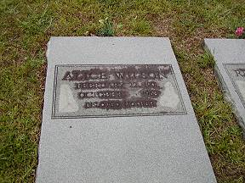
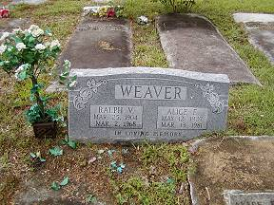 | 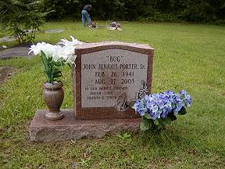
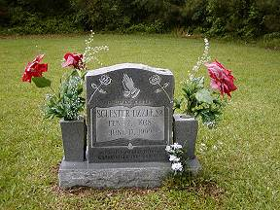 | 