Jenkins ~Jenkins Mill Rd~ Cemetery
Transcribed by members of the
Grave Site Survey Task Force (GSSTF)
Under the Auspices of
Isle of Wight County Historical Society (IWCHS)
Visited March 14, 2021

A selection of shaving foam, water, or talcum powder was used to improve the legibility of the inscriptions on the older tombstones. Afterwards, a clean water spray was used to remove any residue. GSSTF members were careful not to damage tombstones or artifacts during the transcription process.

Any text within the “[ ]” is a comment about the tombstone inscription, ex., [fs] indicates a footstone inscription. Throughout the transcribing process, an attempt was made to preserve the, ‘look and feel’ of the original inscriptions as regards word spacing, arrangement, and possible misspellings.

Please address your comments/corrections to: albert.b@charter.net or epowellsr@aol.com.

 | Inscription |  |  | Inscription
[fs] | In Remembrance of  WILLIAM B. ALLEN,  Died  Nov. 1, 1900  Aged 66 Yrs. 11 mos.  & 28 Days  W.B.A. |  | [fs] | FANNIE B. JENKINS  Born  Jan. 22, 1861  Died  June 18, 1886  F.B.J.
[fs] | FANNIE E. ALLEN  Wife of  W.B. ALLEN  Born  July 11, 1831  Died  March 27, 1896  F.E.A.
 | 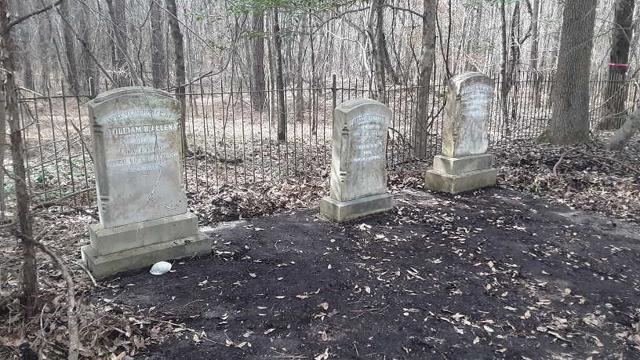 |  |  | 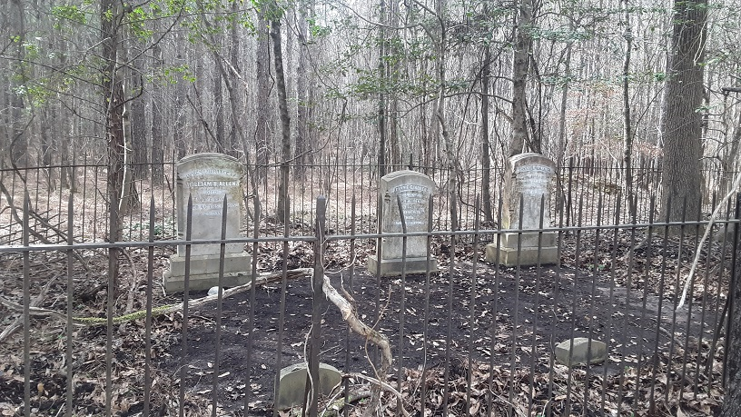
 | 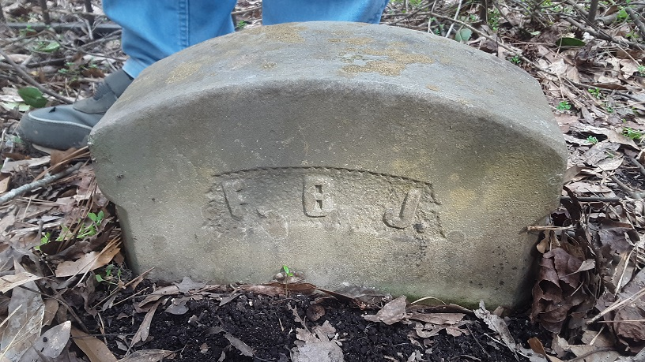 |  |  | 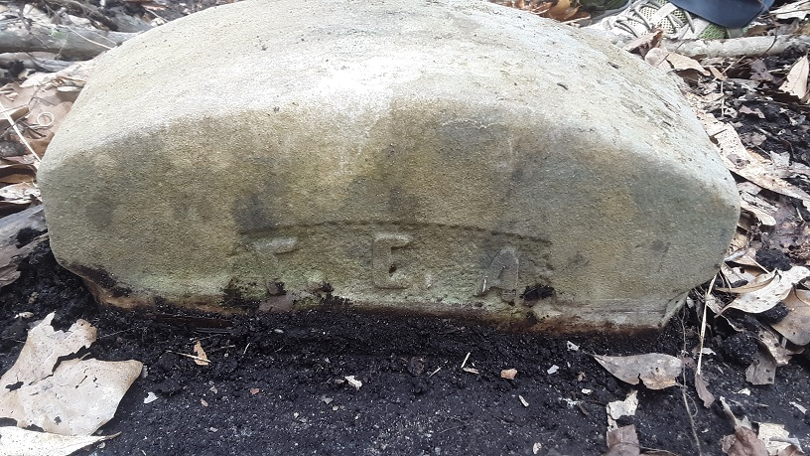
 | 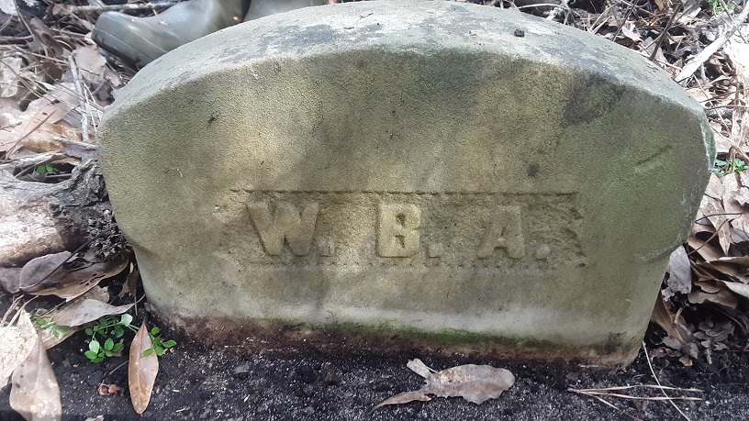
 | 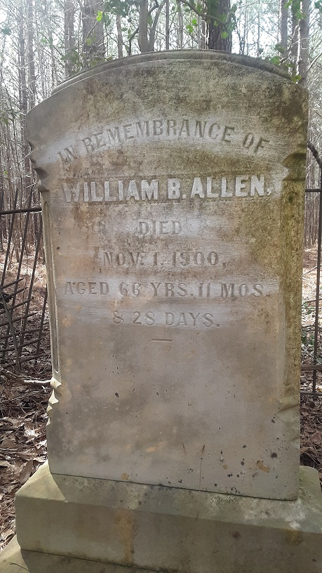 |  |  | 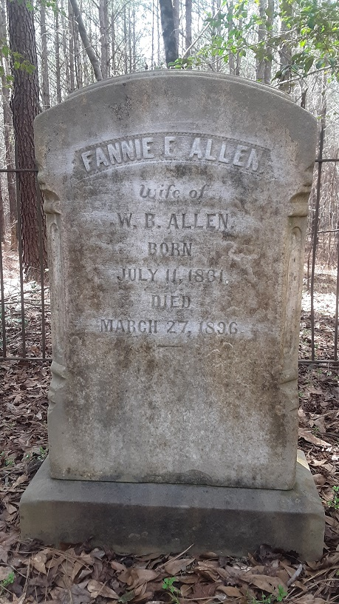
 | 