Johnson--Walters Hwy--Cemetery
Transcribed by members of the
Grave Site Survey Task Force (GSSTF)
Under the Auspices of
Isle of Wight County Historical Society (IWCHS)
Visited September 25, 2013

Location: In the front yard of “Sparky Jenkins old homeplace” on Walters Hwy

A selection of shaving foam, water, or talcum powder was used to improve the legibility of the inscriptions on the older tombstones. Afterwards, a clean water spray was used to remove any residue. GSSTF members were careful not to damage tombstones or artifacts during the transcription process.

Any text within the “[ ]” is a comment about the tombstone inscription, ex., [fs] indicates a footstone inscription. Throughout the transcribing process, an attempt was made to preserve the, ‘look and feel’ of the original inscriptions as regards word spacing, arrangement, and possible misspellings.

Please address your comments/corrections to: albert.b@charter.net or webmaster@iwchs.com

 | Inscription |  |  | Inscription
 | Son  ISAAC N.  1854 – 1860 |  |  | JOHNSON  Mother  MARY COTTON  1822 – 1892  Dau. Of HENRY P.  And BELVEY ALLEN  COTTON
 | Son  FRANCIS HARDY  1843 -------------- 1862  Isle of Wight  Avengers  61st VA. Inf. 1861  CSA |  |  | JOHNSON  Father  JESSE B.  1806 ----------- 1896  Son of  JACOB and  PATIENCE B.

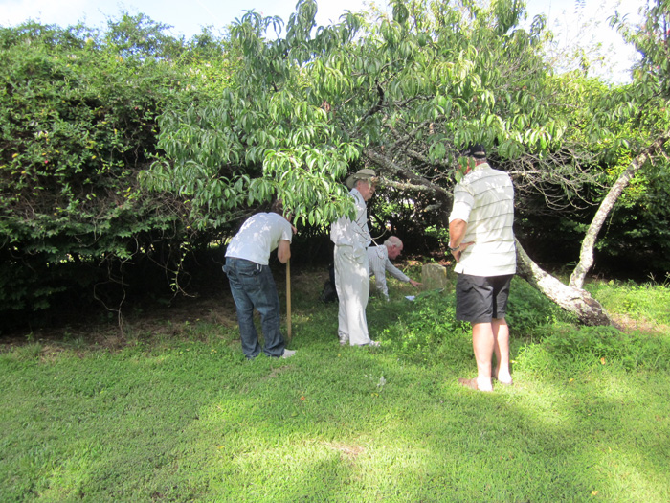 | 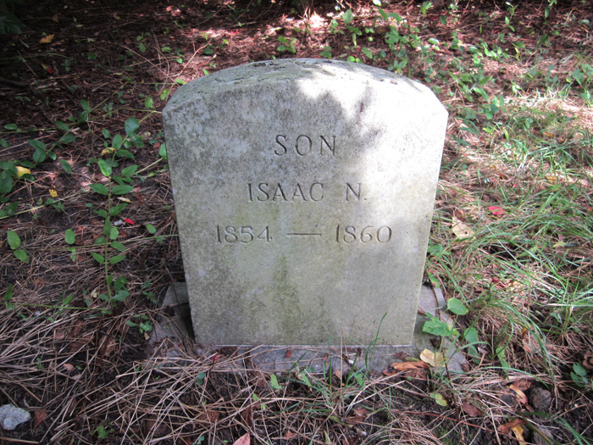
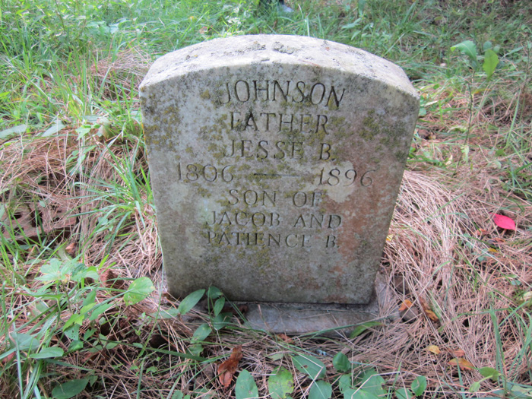 | 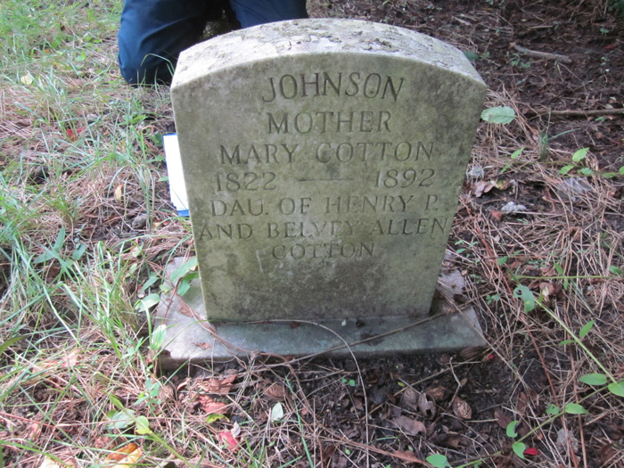
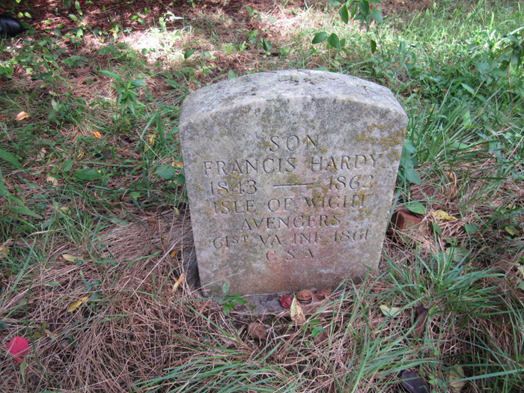 | 