Johnson ~Buckhorn Dr~ Cemetery
Transcribed by members of the
Grave Site Survey Task Force (GSSTF)
Under the Auspices of
Isle of Wight County Historical Society (IWCHS)
Visited December 7, 2005

A selection of shaving foam, water, or talcum powder was used to improve the legibility of the inscriptions on the older tombstones. Afterwards, a clean water spray was used to remove any residue. GSSTF members were careful not to damage tombstones or artifacts during the transcription process.

Any text within the “[ ]” is a comment about the tombstone inscription, ex., [fs] indicates a footstone inscription. Throughout the transcribing process, an attempt was made to preserve the, ‘look and feel’ of the original inscriptions as regards word spacing, arrangement, and possible misspellings.

Please address your comments/corrections to: albert.b@charter.net or epowellsr@aol.com.

 | Inscription |  |  | Inscription
 | Mrs. NANCY NURNEY  Widow of the late  HARRISON NURNEY,  Aged 86 years  ----  Sweet was the time when first I felt,  The Saviour’s pardoning blood,  Applied to cleanse my soul from guilt  and bring me home to God. |  |  | ELIZABETH  NURNEY DUNSTON  Beloved Wife of  MILTON DUNSTON  July 2, 1841  July 20, 1920  Asleep in Jesus
 | MILTON  DUNSTON  Age 79 years  Born 1845  Died 1924 |  |  | JUNIOUS G.  Son of  S. J. & MISSOURI G.  BRADSHAW  Born Apr. 19, 1831  Died Dec. 11, 1881  At Rest
Note (1) | CHARLIE H.  Son of  S. J. & MISSOURI  BRADSHAW.  Born Dec 26, 1882  Died June 9, 1899  Though Thou art  gone  Fond memry clings  to thee |  |  | Our Mother  M. E. JOSEPHINE  Wife of  MILTON J. BUTLER:  Oct. 7, 1846  Apr. 5, 1875  Asleep in Jesus.
 | In memory  of  MYRA ANN  Beloved wife of  B. R. JOHNSON  Born Oct. 12, 1851,  Died May 17, 1874,  Age 22 yrs. 17 mo. & 5 days.  ----  Asleep in Jesus blessed sleep  from which none ever wake to weep  a calm and undisturbed repose  unbroken by the last of foes  A.S. Orourke |  |  | Our Mother  SARAH JOHNSON  Born  June 18, 1810.  Died  March 17, 1881.  ----  “Gathered in a good  old age to the  assembly of the  righteous”  S.J. [fs]
 | In Memory of  BENJAMIN R.  Devoted Husband of  LUCY A. JOHNSON.  Born  Apr. 6, 1845  Died  June 26, 1886  Go to thy grave in all thy glorious prime,  In full activity of zeal and power:  A Christian cannot die before His time,  The Lord’s appointment is the servants hour.  B.R.J. [fs] |  |  | In Memory of  L. KATIE,  Daughter of  B. R. & LUCY A. JOHNSON  Born Oct. 11, 1889  Died Nov. 15, 1895  ----  [epitaph is not legible]
 | Father  JOSHIA BRADSHAW  Sept. 20, 1817  Oct. 3, 1902  A sleep in Jesus,  Blessed sleep  J.B. [fs] |  |  | LILLIE MYRA  Infant Daughter of  E. J. EMILINA DARDEN  Born June 10, 1892  Died Oct. 30, 1895  [scripture at bottom of stone but is illegible]

Notes:
(1) The word, “memry” is actually engraved on the stone … not a typo.

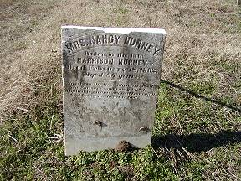 | 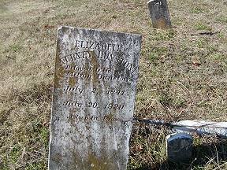
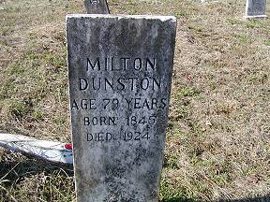 | 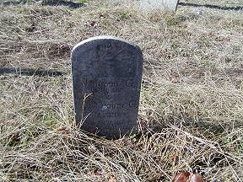
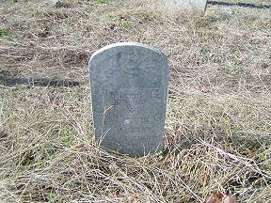 | 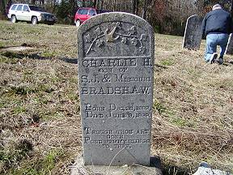
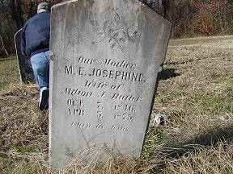 | 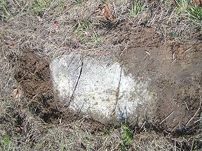
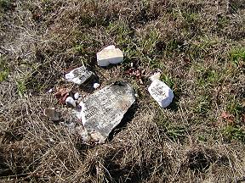 | 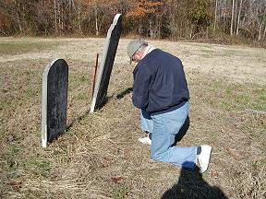
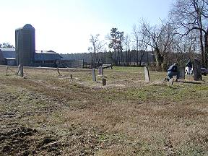 | 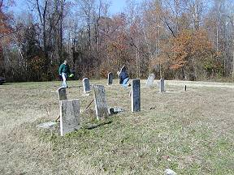
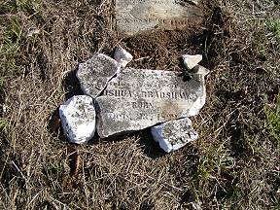 | 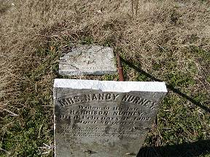
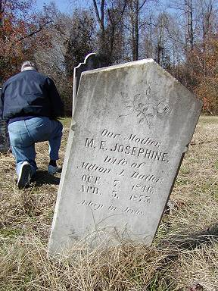 | 